Matilda Centre Strategy at a Glance
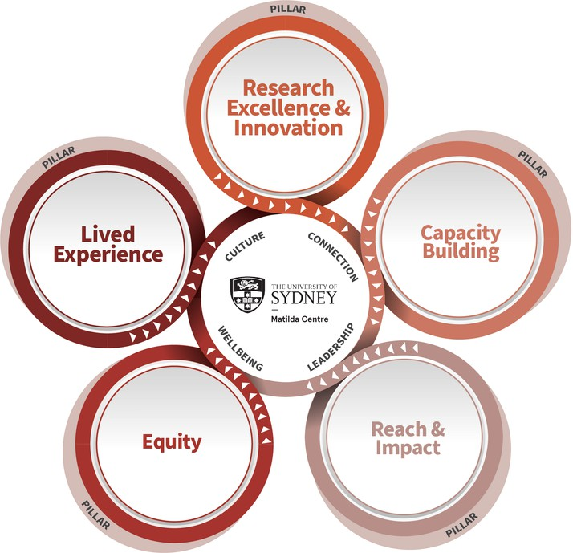
2025-2029

Mission
To be at the forefront of research for the detection, prevention and treatment of mental and substance use disorders.

OUR

Vision
A healthier tomorrow for everyone

Values
Passion and commitment; Scientific rigour, integrity and innovation; Collaboration, engagement and teamwork; Courage and perseverance; Inclusivity, equality and social justice

RESEARCH EXCELLENCE AND INNOVATION


New knowledge of causes and risks: uncovering risk and protective factors for mental health and substance use disorders
Identify new targets for intervention through cutting edge causal modelling, epidemiology neuroscience and biostatistics
Agile prevention: addressing emerging concerns and contemporary issues for youth and the entire lifecourse
Optimise, adapt, develop and trial interventions aimed at halting, delaying, and interrupting the onset, progression and co-occurrence of substance use and mental disorders
Novel treatments: shifting the treatment landscape for mental and substance use conditions and their co-occurrence
Grow treatment impact through novel clinical research, development and translation of multiple morbidity programs and resources
Field building: harnessing the impact of evidence-based translation into practice and policy
Strengthen implementation to build the evidence base for increased research, policy and community impact

CAPACITY BUILDING
Increased research capacity: supporting and developing tomorrow’s research leaders
Attract, value, build and support career pathways of world-class HDR students, EMCRs and professional staff
A sustainable Centre: managing growth and strategic opportunities
Diversify funding sources and build internal capacity to effectively select and leverage strategic opportunities for well- funded research
Values-aligned leadership: promoting research leaders that stand out
Strengthen development of research leaders in academic, government, policy and public spheres with a reputation for excellence and compassion
A community of researchers: creating broad research capacity
Expand research capacity among key stakeholders and priority populations, including clinicians, Aboriginal and Torres Strait Islander peoples and those with lived experience
REACH AND IMPACT
Effective dissemination: targeted translation for diverse populations
Strengthen our engagement with community, stakeholders, youth and people with lived experience to understand and deliver to context and needs
Advocacy and thought leadership: recognised as a trusted leader in mental health and substance use
Communicate research excellence and the strong evidence base providing trusted messaging for diverse audiences
Monitoring meaningful outcomes: measuring our research impact
Meaningfully capture reach and impact at the individual, project, centre and community levels







EQUITY
Compassion: recognising the complexity of social drivers of mental health and substance use
Challenge funders, researchers, service providers and policy makers to consider social determinants in all aspects of research, funding, policy and care
Courage: undertaking challenging research where it matters
Strengthen our capacity to tackle complexity and intersectionality head-on in our research
Engagement: ensuring that research outcomes are accessible and broadly applicable
Develop resources that are accessible and meaningful to the people and communities who need them
LIVED EXPERIENCE

Co-produced research and translation: Aligned with national and international lived experience research best practice
Establish effective co-production practices and procedures across all stages of research

Enhanced mutual capacity: Lived experience experts and researchers who recognise and implement the values of lived experience across the lifespan and at all stages of research

Attract, value, and maintain a lived experience experts and research workforce and provide support and opportunities for mutual knowledge sharing

Lived experience research leadership: Enhancing impact of lived experience leadership within and outside the centre
Strengthen valued lived experience engagement and leadership in mental health and substance use research

