Submission in Response to The Department of Premier and Cabinet Development of a Whole-of-Government AOD Strategy

The Matilda Centre for Research in Mental Health and Substance Use, Faculty of Medicine and Health, The University of Sydney

and
NHMRC Centre of Research Excellence in Prevention and Early Intervention in mental Illness and Substance Use (PREMISE)

Contributors
Professor Katherine Mills, Mr Paul Newman, Professor Cath Chapman, Professor Nicola Newton, Professor Tim Slade, Associate Professor Lexine Stapinski, Professor Frances Kay-Lambkin*, Dr Steph Kershaw, Dr Christina Marel, Dr Katrina Champion, Ms Erin Madden, Ms Samantha Lynch, Ms Kate Ross, Professor Maree Teesson

* University of Newcastle and Hunter Medical Research Institute; Matilda Centre Member

Name of organisation | The Matilda Centre for Research in Mental Health and Substance Use, The University of Sydney
Contact details | Professor Katherine Mills  Director of Early Intervention and Treatment Research

Submitted:
24 March 2023

Suggested citation:
Mills, K., Newman P., Chapman, C. Newton, N., Slade, T., Stapinski, L., Kay-Lambkin, F., Kershaw, S., Marel, C., Champion, K., Madden, E., Lynch, S., Ross, K., and Teesson, M. Submission to the NSW Department of Premier and Cabinet Whole-of-Government AOD Strategy. The Matilda Centre for Research in Mental Health and Substance Use, The University of Sydney. 24th March, 2023.

THE MATILDA CENTRE

The Matilda Centre for Research in Mental Health and Substance Use (“The Matilda Centre”) is a Faculty of Medicine and Health Flagship multidisciplinary research centre at the University of Sydney, committed to improving the health and wellbeing of people affected by co-occurring substance use and mental disorders.

Established in 2018, the Matilda Centre generates innovative and workable solutions to address substance use and mental disorders, which are currently the leading global causes of burden and disease in young people.

Working closely with research collaborators, clinicians and carers, policy makers, educators, people with lived experience and the broader community, the Matilda Centre shares skills, synergises data and harnesses new technologies to develop and trial innovative prevention and early-intervention programs for co-occurring substance use and mental disorders.

We are committed to:

- bringing together globally recognised researchers with a shared commitment to the prevention, early intervention and treatment of mental and substance use disorders
- leading research to build the evidence base for a thriving and empowered younger generation

- engaging with decision-makers and people with lived experience to enact real change

- providing a focal point for researchers, policy leaders and clinicians.

The Matilda Centre hosts the NHMRC Centre of Research Excellence in Mental Illness and Substance Use: PREMISE. Funded in 2018 by the Australian National Health and Medical Research Council, PREMISE is a world-first synergy of the leading prevention and early intervention research and translation programs in mental health and addiction across five Australian Universities.

EXECUTIVE SUMMARY
We congratulate and strongly support the NSW Department of Premier and Cabinet for initiating a broad and inclusive program towards the development of a Whole-of-Government AOD Strategy.
This program is founded in the extensive Government evaluation of the challenges posed by the substantial and increasing issues of crystal methamphetamine (“Ice”) use and harm, and the determination from that inquiry and consultation that the response to alcohol and other drug challenges must be developed in concert: i.e. a focus or reaction to one substance alone is insufficient, and a response or strategy in the context of AOD or substance use shifts the focus of transformation from a criminal justice response to a social and health-centred response.
The Consultation Policy Levers framework considered three pillars. The Matilda Centre recognises the critical importance of the Supply and Harm Reduction Pillars, but notes that our expertise and hence this submission focuses on the Demand Reduction Pillar.

The Matilda Centre proposes that three factors are critical for consideration under this paradigm shift towards a social and health-centred strategy:
- The introduction and escalation of prevention modalities
- The recognition of AOD comorbidity with mental health, and the need to address the personal, social and community challenges posed by substance use together with mental health
- The critical importance of the voice of lived experience; with a subset of relevance in this domain the reduction of stigma.

The Matilda Centre contributed extensively to the NSW Special Commission Of Inquiry Into The Drug ‘Ice’. The current submission builds on and extends this work, reinforcing our focus on the importance of prevention and co-morbidity, and the extensive evidence-base that provides avenues and opportunities for the development and extension of effective prevention programs.
The Matilda Centre is a world-leader in the development, evaluation and implementation of prevention programs in mental health and substance use, and this report will review some of our more extensive and successful programs, programs in development and gaps identified where future work may play an important role in NSW AOD preventive strategy.
The Matilda Centre emphasises the importance of increasing access to evidence-based information and resources in NSW, which is achievable, quickly and effectively, through the promotion of prevention and comorbidity portals such as:
- The national Cracks in the Ice portal which includes resources for Aboriginal and Torres Strait Islander peoples
- The Positive Choices Portal, providing resources including for other alcohol and other drugs
- the Family and Friends Support Program, promoting the importance of resources and support for those supporting others
- The Comorbidity Guidelines, providing evidence-based guidance for the clinical management of people needing AOD and mental health care.

These and other resources are based on a strong foundation of evidence and are well received by the community and professional clinicians, care workers, etc.
Increased promotion and support for more comprehensive access to and uptake of these resources in NSW, as well as support for the development of additional resources to fill identified gaps in reach and content (e.g. adaptions for young people and peer workers) will play a substantial part in the implementation of a NSW AOD strategy.
The involvement of people with lived experience, including those as peer workers and general consultants, in the development of strategy and policy is critical to ensure that policies and practices are relevant and effective for the target audiences. The Matilda Centre has implemented powerful and embedded models of research co-design, which contribute significantly to the development and effectiveness of prevention and other programs.
The Matilda Centre also recognises the vital nature of ongoing surveillance and monitoring both to track trends in alcohol and other drug use, and co-occurring mental disorders, and to identify contemporary and emerging risk and protective factors. The identification of new risk and protective factors feeds into the development of new prevention and early intervention programs.

STRUCTURE OF THIS SUBMISSION
Aligned with the central themes outlines in the Executive Summary, this submission:
- Provides a brief Background
- Proposes and develops the importance of 1. Prevention in a paradigm-changing Whole-of-Government approach to AOD, and introduces the suggested modes of action and opportunities with Matilda Centre examples for strategic change:
  - Mode 1. Strengthen prevention by increasing access to evidence-based information and resources
  - Mode 2. Prevention and early intervention programs
  - Mode 3. Support for young adults as they transition out of school
  - Mode 4. The important role of family and friends
- Reinforces the need to consider 2. Comorbidity and the co-occurrence of mental health and substance use in AOD strategy and planning
- Raises the critical role of the voice of 3. Lived Experience in the development, implementation and review of AOD strategy, and notes stigma as a significant factor in access to care
- Considers gaps and opportunities for NSW strategic leadership

BACKGROUND
Note: the scope of this submission does not allow for a detailed review of data on drug and alcohol, and mental health prevalence, impact, programs and management in NSW.

As an outcome of the Special Commission of Inquiry into the Drug ‘Ice,’ the NSW Government has initiated a program to develop and implement a Whole-of-Government Alcohol and Other Drug (AOD) strategy and a NSW Drug Action Plan. This approach reflects the conclusion that the issues, challenges, and solutions to any one drug problem require consideration of the broader AOD environment. The Matilda Centre adds the need to consider mental health in concert with discussions, strategy and actions on substance use.

WHAT WE KNOW
- Substance use and mental disorders are among the leading causes of burden of disease in young people globally¹. The peak of this disability occurs in those aged 15-24 years and corresponds with the typical period of onset of these problems², with three in four people with a substance use disorder developing it before leaving school.
- Critically, substance use, depression and anxiety frequently co-occur, share common risk factors and interact^{3, 4}. In Australia, among those aged 12-17 years, 8% binge drink at least monthly, with 4% drinking 11 or more drinks on a single occasion at least monthly, and 14% meet criteria for a 12-month mental disorder, indicating a 1.7-fold increase in major depression among this age group in the last two decades⁵.
- Every year alcohol and other drugs cost the Australian community $23.5 billion and anxiety and depressive disorders cost $12.6 billion⁶, which NSW shouldering a substantial proportion of this cost.
- The burden of substance use and mental disorders now accounts for 1 in every 10 lost years of health globally¹. Despite increases in government spending on mental health in recent years, fewer than 1 in 4 Australians will ever access treatment for their problem⁷.
- Effective prevention is therefore critical to delay first onset, halt the development of disorder, and prevent the onset of co-occurring disorders. Although preventive interventions are cost-effective⁸, currently only 1.7% of total health expenditure in Australia is spent on prevention, less than two thirds of all other OECD countries⁹.

CONCLUSION
As substance use disorders, depression, suicide, anxiety, and psychosis frequently co-occur, share common risk factors, and interact, an integrated approach to substance use and mental illness is critical¹⁰⁻¹³.
The Matilda Centre supports broad systematic and strategic models to break down silos between mental health and substance use prevention and care.
Whilst the Matilda Centre has a strong focus and expertise in youth-based prevention, the Centre spans a whole-of-life approach to prevention, care and support through evidence-based programs, interventions, resources and guidelines.
The NSW Whole-of-Government approach provides an opportunity for ambitious strategic reforms in mental health and substance use prevention and treatment, as a foundation to Supply Reduction and Harm Reduction and the effects of regulation, justice and enforcement.

PREVENTION: THE FOUNDATION TO HARM REDUCTION

Mode 1. Strengthen prevention by increasing access to evidence-based information and resources in NSW
Ensuring people have access to evidence-based information about AOD, including the effects of AOD, managing use, seeking help and supporting friends and family can help prevent use of these substances and associated harms. Online approaches to disseminating evidence-based information have the advantage of maximising reach and overcome geographic, structural and attitudinal barriers to accessing information and support via other sources.
Online resources have become the primary sources of information and research across communities, and, through appropriately managed portals, facilitate the promotion of credible research and information, ready review and update, and the provision of tailored resources and information.
However, it is critical to recognise the diversity of access and needs across the State, and hard-copy resources remain central to programs providing evidence-based resources and in high demand.
Matilda Centre Example: Cracks in the Ice
Cracks in the Ice (CITI; www.cracksintheice.org.au) aims to increase access to trusted, evidence-based information and resources about ice via online channels. Developed in response to the Final Report of the National Ice Taskforce, CITI was established in 2015 providing information and answers to common questions in the Australian community, as well as more targeted information and resources for key populations such as family and friends, health professionals and local communities.

The toolkit aims to:
- Prevent initiation of ice use by educating the public about the effects of ice
- Facilitate early intervention for ice use by providing a brief online screening tool for level of use, guidance on where to get help, and evidence-based screening and intervention tools for health professionals working with AOD clients
- Help family, friends and health professionals prevent harms to themselves and others when responding to someone experiencing ice-related issues, and to build capacity among health care professionals working with people who use ice through evidence-based information, guidelines and training
- Reduce stigma and discrimination associated with ice use through the use of non-judgemental language and a focus on evidence-based information.
Since its launch, the toolkit has received traffic from over 972,000 unique visitors and has responded to over 300 requests for information or assistance. Over 280,000 hard copy booklets and flyers have been requested, and CITI webinars see considerable attendance and views. Social media impact includes over 4.4 million Facebook impressions and nearly 450,000 Twitter impressions.
NSW represents approximately 35% of CITI users and is the highest state by reach per head of population.

In 2021 the Matilda Centre launched the first suite of culturally appropriate resources adapted from the CITI toolkit specifically for Aboriginal and Torres Strait Islander peoples, providing relevant, evidence-based, culturally appropriate information and resources for individuals using crystal methamphetamine, families, health workers and community.

Co-designed with Aboriginal and Torres Strait Islander peoples, these resources have been viewed over 53,000 times by more than 25,000 users with 52,000 hardcopy resources distributed around Australia.

More than 28,000 hardcopy resources were ordered within the first three weeks of launch, demonstrating both the community need for culturally appropriate resources and information, and the ongoing need for these resources to be available in multiple formats.
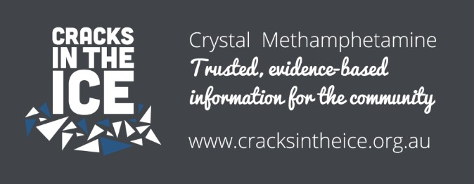

Matilda Centre Example: Positive Choices
School-based AOD and mental health prevention and education has been shown to prevent AOD use later in life¹⁴⁻¹⁷, and it is critical that teachers, parents and students have access to evidence-based resources. Positive Choices (www.positivechoices.org.au) is a national drug prevention portal that addresses a known gap in the implementation of evidence-based drug prevention in Australian schools. Developed in consultation and collaboration with over 200 teachers, parents and students, the portal provides centralised access to more than 100 drug prevention resources specifically for school staff, parents, students, Aboriginal and Torres Strait Islander peoples, and Culturally and Linguistically Diverse peoples.
By harnessing contemporary digital technologies and social media, Positive Choices dramatically expands the scope and reach of evidence-based drug prevention, equipping parents, schools and staff to respond effectively. Ongoing community engagement, annual review and updates ensures Positive Choices stays current and responds to emerging issues and information needs of school communities.

Positive Choices web resources have been viewed more than 5.8 million times by nearly 3 million users, have had over 13 million Facebook and Twitter impressions, with hardcopy drug and alcohol education booklets distributed to more than 317,000 to schools and community groups across Australia.
Positive Choices alcohol and other drug expert webinars have seen over 25,000 views either live or on-demand, and Positive Choices has facilitated ‘Primary Prevention’ webinar series for NSW Community Drug Action Teams (CDATs).
Over 36% of Positive Choice visitors are from NSW, and NSW Health staff have been particularly instrumental in the development of resources for Culturally and Linguistically Diverse parents. Positive Choices worked closely with the Illawarra and Shoalhaven Local Health District, and with feedback from parents and Multicultural Healthcare Workers, developed culturally adapted and translated resources in Arabic, Hindi, and Simplified Chinese. Similarly, the development of resources for Aboriginal and Torres Strait Islander students with translation into three Indigenous languages (Arrernte, Torres Strait Islander Creole, and Warlpiri) was informed by consultations with NSW Health, the Australian Indigenous Health Info net and Department of Family and Community Services.
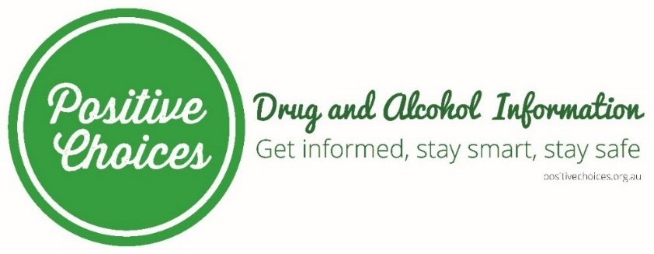

Opportunity
With online spaces becoming increasingly crowded and advertising markets ever more competitive, more can to be done to increase awareness of these and other AOD and mental health trusted and creditable health web resources in NSW.
There is opportunity for NSW to lead in promotion and ensuring a consistent evidence-based voice is provided to the community and people working in AOD and mental health through the ongoing development of effective information tools.

Mode 2. Prevention and early intervention programs

Adolescence represents a critical window to equip young people with the skills they need to lead healthy lives, and schools offer the ideal location to intervene. There has been a substantial increase in the number of school-based prevention programs developed, yet the majority continue to show modest or no effects, and the uptake of these programs remains low^{17, 18}. It is critical that we increase program efficacy by developing innovative interventions that overcome barriers to implementation and sustainability. Incorporating eHealth in prevention science is showing great promise as online technologies can increase implementation fidelity, enhance student engagement, and enhance translational outcomes by improving sustainability and scalability¹⁹.

Curriculum-based, skill-building programs are essential to building resilience and preventing mental disorders among young people. Trials to evaluate school-based prevention programs for depression, anxiety, suicide and AOD/substance use have shown them to be both effective and cost-effective^{16, 20}.

In addition to preventing the development of mental and substance use disorders, which have a well-documented impact on absenteeism and productivity, there is evidence that school-based prevention programs can directly improve rates of school attendance and that integrated approaches to the prevention of mental health and substance use can have beneficial effects in reducing anxiety and alcohol use^{21, 22}.

Effective prevention and early intervention can significantly reduce disease burden by halting, delaying, and interrupting the onset and progression of disorders^{14-17, 23, 24}. Prevention in young people also encompasses preventing transition to AOD use in young people at risk (e.g., with anxiety, depression, or related mental health problems), and providing programs that intervene early in a young person’s mental health journey to assist them to develop strategies that promote resilience, coping, improved physical health, and alternative pathways to drinking alcohol and using other drugs.
Matilda Centre Example: Our Futures
Our Futures – https://ourfutures.education/ (formerly Climate Schools) is a suite of universal prevention programs that utilise interactive cartoon storyboards to engage and educate secondary students, empowering them to improve their health and wellbeing. There are currently five evidence-based modules covering:
- Alcohol: Year 8
- Alcohol and Cannabis: Years 8-9
- Cannabis and Psychostimulants: Years 9-11
- Ecstasy and Emerging Drugs: Years 10-11
- Mental Health: Years 8-10.

Co-designed with over 160 young people and 380 teachers, parents, and health and education experts, each module includes 4-6 lessons supported by optional teacher-facilitated class activities. The lessons are grounded in the Social Influence Theory, providing developmentally appropriate information about ATOD and mental health, resistance skills training, and normative education.

The lessons require no formal teacher training and include unit plans created by an expert curriculum consultant mapping content to the NSW PDHPE Syllabus, and addressing syllabus outcomes and skills.

The Our Futures programs have been rigorously evaluated in seven large randomised controlled trials with over 14,600 students from 169 schools in Australia. Compared to health education as usual, students who undertook the Our Futures programs showed reduced:
- psychological distress and slowed progression of anxiety symptoms
- alcohol consumption and binge drinking
- Cannabis and ecstasy use
- Reduced harms from substance use and improved knowledge about mental health and alcohol and other drugs

These outcomes were maintained for at least 3 years following the interventions.

The most recent assessment of 3 year follow-up of students using the Our Futures program showed a 64% reduction in the uptake of binge drinking²⁵. If universally delivered to secondary students in Australia, this would equate to 120,000 fewer adolescents binge drinking and 1,000 less hospital admissions each year for young people with alcohol-related harms.

The Our Futures programs are well received, with 93% of students finding the cartoons an enjoyable and interesting way to learn, and 95% of teachers rating the education quality of the programs as high. Our Futures has reached over 1,140 schools, over 32,000 students, over 2,700 teachers and health services in Australia.

This influential program of research and school-based AOD and mental health intervention has revolutionised school-based prevention education, informing national and international policy and practice.


Matilda Centre Example: Preventure

Preventure is an international evidence-based program to reduce substance use and improve mental wellbeing among high school students. Through eight randomised controlled trials, Preventure has demonstrated effectiveness in reducing alcohol use, binge drinking, and alcohol-related harms by 30-50%, and in Australia the program was additionally found to reduce psychological distress, anxiety, depression, conduct problems, and hyperactivity with sustained benefits for three years^{26, 27}.

To adapt the program into practice in Australia, extensive consultation was undertaken with students, teachers, industry and drug and alcohol experts and the community through focus groups. Support from agencies including NSW Health has seen Preventure training to over 200 school staff (counsellors, wellbeing officers) and drug and alcohol workers, in urban and regional areas, with 78% working with Aboriginal and/or Torres Strait Islander students.

NSW Health further funded a translation of Preventure to non-school settings, to extend the reach to young people who may not be attending school. This resulted in a NSW Health-sponsored and subsequent Preventure Australia training workshops for drug and alcohol counsellors, school staff, drug and alcohol workers, LHD staff, youth workers, and educators.

Matilda Centre Example: HEALTH4LIFE

Health4Life (https://health4life.org.au/) is a world-first eHealth intervention to concurrently prevent the “Big 6” lifestyle risk factors for chronic disease: alcohol use, tobacco, physical inactivity, poor diet, poor sleep and excessive recreational screen time. Underpinned by a multiple health behaviour change approach – targeting behaviours together, rather than in isolation, the Health4Life program aims to empower youth to reduce chronic disease risk and improve wellbeing by providing simultaneous education about the Big 6.²⁸

Co-designed with youth and teachers across Australia, Health4Life consists of a universal school-based program delivered to Year 7 students, regardless of their risk for chronic disease, and an accompanying smartphone app. Health4Life reinforces the importance of multidisciplinary teams and the need to consider health challenges in a broader context, spanning the fields of mental health, addiction, physical activity, exercise physiology, dietetics and behaviour change.

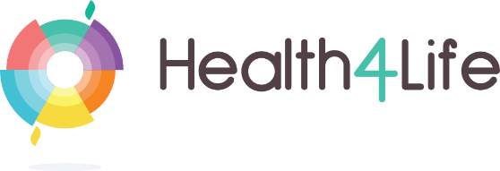

Opportunity
It is strongly recommended that the NSW Government incorporate into strategy and action planning investment in the implementation of evidence-based, scalable, school-based and other programs to prevent mental and substance use disorders.

There is a critical need to implement state-wide strategies aimed at supporting schools and
educators to deliver prevention programs that have been rigorously evaluated and found to decrease the risk of mental disorders and harms relating to drug and alcohol use. It is recommended that schools be supported through a framework to develop a sustainable structure to implement evidence-based, curriculum-aligned universal and selective prevention programs.

Action Planning might include:
- Funding to support school licences for evidence-based prevention programs;
- Provision of professional learning activities, online resources and training modules to empower school communities to implement evidence-based drug prevention principles and practices tailored to their school and local environment;
- Support to co-ordinate across and integrate mental health and substance use prevention initiatives;
- Support for high-risk young people and communities through a coordinated approach between schools and established services and programs addressing mental health and substance use issues and that leverages technology to provide a wraparound support service for at-risk young people.

Mode 3. Support for young adults as they transition out of school
Emerging adulthood, 18–25 years, is a critical developmental period when young people have increased exposure to risk behaviours, such as alcohol and other drug use while also acquiring greater autonomy over their food and lifestyle choices. Young adulthood in Australia is characterised by a peak in alcohol use²⁸: within a 12 month period, 1 in 3 young adults consume alcohol at very high risk levels⁵, and alcohol is among the leading contributors to total burden of death, disease and injury in this age group²⁹. An accumulating body of evidence suggests that young people with symptoms of mental illness, such as anxiety or depression, are particularly susceptible to hazardous alcohol use and related harms³⁰.

In addition to school-based approaches to prevent substance use and mental disorders, it is vital to support young adults as they transition out of school. The transition to adulthood is associated with unique personal and social role changes, such as commencing new employment or study, new living arrangements, and increased autonomy and responsibility. This post-school period is an important opportunity to reinforce and strengthen the skills they learned while at school, or to assist those young people who require additional support to acquire these skills or to navigate the challenges of emerging adulthood.

Mode 4. The important role of family and friends
The effects of AOD and mental health extend well beyond the individual and can additionally have a profound impact on family members and friends. Supporting someone experienced a substance use or mental health issue, or both, can be extremely challenging, isolating and emotionally distressing. Families and friends can also play a critical role in prevention, treatment and recovery, however these relationships often break down, leaving the person affected isolated. Increasing access to support services, information and tools for families and friends is important for reducing the impact of mental health and substance use issues, and may also help build their capacity to support through recovery. It is unusual for AOD services to be funded to provide support directly to family members and friends, and this often takes the form of supporting the family member/friend to encourage treatment seeking, and in supporting that person’s journey towards recovery. However, family members and friends themselves are at high risk for developing mental health and AOD problems of their own, and require support tailored to their unique experiences of supporting a loved one.

The Family and Friends Support Program (FFSP; www.ffsp.com.au) is an online resilience and wellbeing program to support affected friends and family members, initially developed for people who use methamphetamine, and now expanded to support families and friends of people using ice, and alcohol and other drugs, and to respond to trauma isolation in rural areas in the wake of COVID-19. Serving as a model of the importance of family, friend and peer support and education in mental health and substance use/AOD, the programs have been accessed by more than 16,000 people.

The FFSP program provides impacted family and friends with a tailored, evidence-informed website and support program that addresses the needs of those supporting a loved one, and is the first and only evidence informed program worldwide to offer 24/7 support to family members and friends affected by crystal methamphetamine, alcohol and other drugs.


Comorbidity
More than one-third of people with an AOD-use disorder have at least one co-occurring mental disorder, and the rate is even higher among those in AOD treatment programs. Additionally, there are a large number of people who present for AOD treatment who display symptoms of mental disorders, while not meeting the criteria for diagnosis of a disorder.

The high prevalence of co-occurring AOD and mental health conditions means that AOD workers are frequently faced with the need to manage complex psychiatric symptoms whilst treating AOD use³³. Clients with co-occurring mental health conditions often have extensive trauma histories, and a variety of other medical, family, and social factors such as housing, employment, welfare and legal problems. AOD workers must therefore adopt a holistic and trauma-informed approach to the management and treatment of co-occurring conditions that is based on treating the person, not the illness.

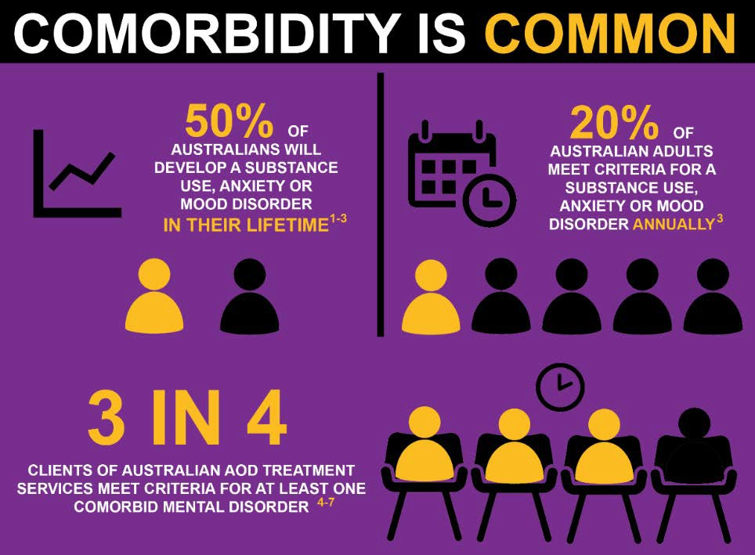

The economic burden of these conditions is significant. Estimates show that in Australia, the annual cost of premature death owing to co-occurring serious mental health and substance use conditions is $45 billion. It is critical that AOD treatment services are well equipped to address both substance use and mental health issues to produce the best results for clients.

Strengthening the response of health workers in the AOD and mental health sectors to co-occurring mental health issues is key to improving treatment outcomes and there are clear opportunities for national leadership in NSW.
Factors for consideration in the development of strategy and action planning for AOD and mental illness include:

- First, do no harm. Work within capacity and engage in ongoing professional development
- Recognise that the management of co-occurring conditions is part of AOD workers’ core business
- Provide equity of access to care, adopt a ‘no wrong door’ policy
- Recognise that co-occurring conditions are common and that all clients should be routinely screened for co-occurring conditions
- Conduct ongoing monitoring of symptoms and assessment of client outcome
- Focus on engaging the client in treatment
- Adopt a client-centred, holistic approach based on treating the person, not the illness
- Adopt a trauma-informed care approach.
- Emphasise the collaborative nature of treatment and have realistic expectations
- Express confidence in the effectiveness of the treatment program
- Adopt a non-judgemental attitude and a non-confrontational approach to treatment
- Involve families, carers and peers in treatment
- Consult and collaborate with other health care providers, and promote greater collaborative care with other services
- Ensure continuity of care.

Matilda Centre Example: Comorbidity Guidelines
The Comorbidity Guidelines (https://comorbidityguidelines.org.au/guidelines/) provide alcohol and other drug (AOD) workers with evidence-based information to assist with the management of co-occurring AOD and mental health conditions. The Guidelines:
- Address the nature and extent of co-occurring AOD and mental health conditions, and the importance of AOD services to respond, and provides information on the prevalence, guiding principles, and classification of disorders
- Provide information regarding responding to co-occurring conditions, including holistic health care, trauma-informed care, identifying co-occurring conditions, assessing risk, coordinating care, approaches to co-occurring conditions
- Include worker self-care
- Address managing and treating specific disorders and specific population groups.

THE CRITICAL IMPORTANCE OF LIVED EXPERIENCE

The involvement of people with lived experience of mental health and substance use is essential to improving outcomes in AOD and mental health.

Matilda Centre Example: Youth Advisory Board

The Matilda Centre and PREMISE Youth Advisory Board (YAB) was established to engage and involve young people in research and policy direction. The YAB provides input into governance and research priorities, and contributes to youth-focused mental health and substance use research projects, Matilda Centre and PREMISE community and outreach initiatives and policy workshops and submissions.

The YAB comprises a group of 10 young people aged between 16-25, and are an inspiring and culturally, linguistically and gender diverse group with members from metropolitan, rural, regional and remote areas of Australia with representation from Aboriginal & Torres Strait Islander (4 members) and LGBTQI+ youth.

YAB members have contributed to 36 research projects, 3 reports and policy submissions, a Summit to inform national research priorities, a public youth mental health forum (>1000 attendees) and are co-leading a national youth priorities project with input from >700 young people around the country.

STIGMA
Negative public attitudes about those who use alcohol and other drugs in Australia are widespread³⁴. Stigmatising attitudes are more common among those with less accurate knowledge, and are associated with reluctance to seek support in those who use alcohol and other drugs. Both stigma and need for support or care are significantly higher among those in regional areas and a strong evidence-base, co-design and online access to resources and services were identified as critical to achieve meaningful change. Providing people with sources of information that offer trusted, evidence-based, non-judgemental AOD and mental health information is a critical step towards overturning the stigma.

It is vital that the NSW government leads media outlets and the workforce to use evidence-based, non-stigmatising language and practice when communicating with the Australian public about drug use, mental health and related harms, to help reduce stigma and discrimination, and reinforce the availability of open and safe pathways for treatment and care.

GAPS AND OPPORTUNITIES FOR NSW STRATEGIC LEADERSHIP

The following summarise some of the gaps and opportunities for NSW Whole-of-Government Strategy and Action:

NSW Geography and Population
- Rural, regional, remote: tailoring prevention and information initiatives to broad NSW geographies
- Indigenous youth and communities
- At-risk youth
- CALD and ESL youth and communities
- NSW Health evidence check highlighted the critical role that peers play in reinforcing both positive and negative attitudes and behaviours around the initiation of AOD use and engaging in treatment for AOD-related harms, proposing the development of peer-led interventions
- Reduction in stigma

Science, Data and Evidence
- Increase the scientific knowledge of causes and risks of substance use and mental disorders
- New evidence and an increased evidence base for effective prevention and early intervention in substance use and mental disorders
- Sustainability, development and uptake of proven evidence-based models and interventions
- Epidemiological and broader understanding of social determinants such as childhood, income, education, employment, housing, cultural and social context
- Consistent measuring of AOD, population mental health, mental well-being and mental illness using scales such as:
  - Mental Health Continuum Short Form; Warwick-Edinburgh Mental Wellbeing Scale; Short Form Health Survey (SF-36); and for mental ill-health: The Kessler 6 (K6) and Kessler 10 (K10); The Patient Health Questionnaire; The Generalised Anxiety Disorder scale; The Strengths and Difficulties Questionnaire (SDQ)
  - The Alcohol Use Disorders Identification Test (AUDIT), and the Alcohol, Smoking and Substance Involvement Screening Test (ASSIST).
- Leverage of digital technologies for interventions and education

REFERENCES
- Erskine H., et al. (2015). A heavy burden on young minds. Psychological Medicine, 45, 1551-63.
- Degenhardt L., et al. (2016). The increasing priority of substance use. The Lancet Psych, 3, 251-64.
- Carragher N., Newton N., et al. (2015). Structure of adolescent psychopathology. Psych Med,1-14.
- Teesson M., et al. (2009) Comorbidity in Australia. ANZJP, 43, 606-14.
- AIHW (2016). National Drug Strategy Household Survey detailed report 2016. Canberra.
- Collins D., et al. (2008). The costs of tobacco, alcohol and illicit drug abuse. Canberra.
- Slade, T., et al (2009). National Survey of Mental Health & Wellbeing, ANZJP, 43, 594-605.
- Mihalopoulos C., et al. (2013). The Cost-effectiveness of Interventions Designed to Prevent Mental Disorders: A Literature Review. Early Intervention in Psychiatry 9, 85-92.
- OECD (2013). Health at a glance, 2013. Paris: OECD Publishing.
- Andrews, G., et al. (2004). Utilising survey data to inform public policy: Comparison of the cost-effectiveness of treatment of ten mental disorders. Brit J Psychiat, 184, 526-33.
- Thompson, A., Hunt, C., Issakidis, C. (2004). Why wait? Reasons for delay to seek help for mental health problems in an Australian clinical sample. Soc Psych Psych Epid, 39, 810-817.
- Corry, J., et al. (2004). Evidence-based care for alcohol use disorders is affordable. J Stud Alcohol, 65, 521-29.
- Corry,J., et al. (2004). Child Sexual Abuse. In Ezzati, Lopez, Rodgers & Murray (Eds.) Comparative Quantification of Health Risks: Global and Regional Burden of Disease Attritutible to Selected Major Risk Factors. (pp. 1851-1940). Geneva: World Health Organization.
- Champion, K., et al. (2013) A systematic review of school-based alcohol and other drug prevention programs facilitated by computers or the internet. Drug Alcohol Rev, 32(2): p. 115-23.
- Foxcroft, D.R. and Tsertsvadze, A. (2011) Cochrane review: Universal school-based prevention programs for alcohol misuse in young people. Cochrane Database of Systematic Reviews, 5. Art. No.: CD009113.
- Teesson, M., Newton, N.C., and Barrett, E.L. (2012) Australian school-based prevention programs for alcohol and other drugs: a systematic review. Drug Alcohol Rev, 31(6): 731-6.
- Faggiano, F., et al. (2014) Universal school-based prevention for illicit drug use. Cochrane Database of Systematic Reviews, 12.
- Stockings E et al. (2016). Prevention of substance use. The Lancet Psychiatry 3, 280-296.
- Champion K, Newton N et al. (2016). Prevention in the digital age. Curr Opin Psychiatry, 29, 242-9.
- Werner-Seidler A, et al. (2017). School-based depression and anxiety prevention programs for young people: A systematic review and meta-analysis. Clinical Psychology Review, 51: 30-47.
- Newton NC, Andrews G, Champion KE, Teesson M. (2014) Universal Internet-based prevention for alcohol and cannabis use reduces truancy, psychological distress and moral disengagement: A cluster randomised controlled trial. Preventive Medicine, 65: 109-15.
- Teesson M, Newton N, Slade T, Chapman C, et al. (2020). Combined prevention for substance use, depression and anxiety in adolescence: A cluster randomised controlled trial of an online universal intervention. Lancet Digital Health. (published online Jan 3, 2020))
- Munoz, R.F., et al. (2010) Prevention of major depression. Annu Rev Clin Psychol, 6: 181-212.
- Calear, A.L. and Christensen, H. (2010) Systematic review of school-based prevention and early intervention programs for depression. J Adolesc, 33(3): p. 429-38.
- Teesson M., Newton N. et al. (2017). Combined universal and selective prevention for adolescent alcohol use: a cluster randomized controlled trial. Psych Med 22, 1-10.
- Conrod, P. (2016). Personality-Targeted Interventions for Substance Use and Misuse. Current Addiction Reports. 3. 10.1007/s40429-016-0127-6.
- Newton, N. et al. (2022). Effect of Selective Personality-Targeted Alcohol Use Prevention on 7-Year Alcohol-Related Outcomes Among High-risk Adolescents: A Secondary Analysis of a Cluster Randomized Clinical Trial. JAMA Network Open. 5. e2242544. 10.1001/jamanetworkopen.2022.42544.
- Teesson M., et al. (2020) Study protocol of the Health4Life initiative: a cluster randomised controlled trial of an eHealth school-based program targeting multiple lifestyle risk behaviours among young Australians. BMJ Open. 2020 Jul 13;10(7):e035662.
- Teesson M., et al. (2010) Prevalence and correlates of DSM-IV alcohol abuse and dependence in Australia: findings of the 2007 National Survey of Mental Health and Wellbeing. Addiction, 105(12): 2085-94.
- AIHW. 2013 National Drug Strategy Household Survey report. Canberra: AIHW, 2014.
- Hall W.D., et al. (2016) Why young people's substance use matters for global health. The Lancet Psychiatry, 3(3):265-79.
- Hussong A.M. et al. (2011) An internalizing pathway to alcohol use and disorder. Psychol Addict Behav, 25(3): 390-404.
- Fisher, A. et al. (2022). Guiding Principles for Managing Co-occurring Alcohol/Other Drug and Mental Health Conditions: a Scoping Review. International Journal of Mental Health and Addiction. 1-48. 10.1007/s11469-022-00926-7/.
- Deen, H. et al. (2021). Stigma, discrimination and crystal methamphetamine (‘ice’): Current attitudes in Australia. Int J Drug Policy. 87. 102982. 10.1016/j.drugpo.2020.102982.

