SUBMISSION TO THE NSW SPECIAL COMMISSION OF INQUIRY INTO THE DRUG ‘ICE’

Joint submission by:
The Matilda Centre for Research in Mental Health & Substance Use, the University of Sydney
&
The Priority Research Centre for Brain and Mental Health, the University of Newcastle.

The Matilda Centre
Prof Maree Teesson, AC, Director
A/Prof Cath Chapman, Director, Research Development & Strategy, Program Lead, Cracks in the Ice
A/Prof Nicola Newton, Director, Prevention Research, Program Lead, Positive Choices Dr Stephanie Kershaw, Project Lead, Cracks in the Ice
Ms Hannah Deen, Research Assistant, Cracks in the Ice
Ms Samantha Lynch, Research Program Officer, Cracks in the Ice and Positive Choices

Priority Research Centre for Brain and Mental Health
Prof Frances Kay-Lambkin, Deputy Director (Mental Health Hub), Project Lead, Family & Friends Support Program, Cracks in the Ice, Crystal Clear
Prof Brian Kelly, Dean, Faculty of Medicine and Health, Director

Submitted: 7th May 2019

Please cite this submission as:
Kershaw, S., Deen, H., Kay-Lambkin, F., Kelly, B., Lynch, S., Newton, N., Teesson, M. Chapman, C. (2019) Submission to the NSW Special Commission of Inquiry into the Drug ‘ice’. The Matilda Centre for Research in Mental Health and Substance Use, the University of Sydney & the Priority Centre for Brain and Mental Health Research, the University of Newcastle, 7th May, 2019.

ABOUT THE MATILDA CENTRE AND THE PRIORITY RESEARCH CENTRE FOR BRAIN AND MENTAL HEALTH
The Matilda Centre for Research in Mental Health and Substance Use (the Matilda Centre) delivers research programs to prevent, treat and reduce substance use and mental disorders. The work of the Matilda Centre is built upon the success of the formerly-known NHMRC Centre of Research Excellence in Mental Health and Substance Use (CREMS).
Our mission is to improve health and wellbeing through research conducted in collaboration with multi-disciplinary international experts, consumers, carers, policy makers, and other key stakeholders. We will achieve this by:
- bringing together globally recognised national and international researchers with a shared commitment to the prevention, early intervention and treatment of mental and substance use disorders
- building the evidence base for a thriving and empowered youth and
- engaging with decision makers and lived experience to enact real change
With a focus on prevention, treatment and epidemiology, our research streams facilitate knowledge exchange and develop strategic partnerships with the aim of increasing the knowledge base around the effective prevention and treatment of mental and substance use disorders. The Matilda Centre leads the NHMRC Centre of Research Excellence in Prevention and Early Intervention in Mental Illness and Substance Use (PREMISE) which aims to provide a world first synergy of the leading prevention and early intervention research and translation programs in mental health and addiction across five Australian universities.
The Priority Research Centre for Brain and Mental Health (CBMHR) at the University of Newcastle, is focused on increasing our understanding of the brain and mind across the lifespan, in the absence and presence of disease. The CBMHR is a cross-disciplinary group of leading researchers from diverse fields, united by a common goal: To understand (and modify) brain function and factors that influence mental health problems at the molecular, cellular, systems, behavioural, and social levels of analysis. The brain is the body’s most complicated organ and understanding how it works under normal conditions, after injury, in disease, and during stress and ageing, underlies our capacity to treat brain disorders and mental health conditions. Bridging brain science with the study of social elements of health and illness is a key feature of CBMHR. Together, neurobiologists, psychologists, and mental health researchers using the most advanced techniques explore this brain-behaviour nexus.
CBMHR's three cornerstones are:
- foster inter-disciplinary research excellence
- support, train, and promote the next research leaders and
- engage the public via open forums
The two research Centres have been working closely together for the last 15 years and this joint submission is a reflection of that collaboration. Most pertinent to this inquiry is work developing and maintaining the Cracks in the Ice portfolio which is funded by the Australian Government Department of Health and consists of two national portals Cracks in the Ice and Friends and Family Support Program.
Cracks in the Ice (www.cracksintheice.org.au) aims to provide trusted, evidence-based, and up-to-date information and resources about crystal methamphetamine (ice) for the Australian community. The toolkit was launched on April 3rd, 2017 and in the two years since launch it

has had 230,351 unique visitors and 488,717 pageviews. Via the toolkit we have access to the views of many Australians affected by ice use in the form of survey responses and feedback loops built into the site. We have recently conducted a survey of over 2000 community members and the results of this survey have informed the current submission. The Crystal Clear online program (crystalclear.org.au) is an evidence-based online treatment program for people aged 16-30 years who use, or are thinking about using, crystal methamphetamine. The efficacy of the online program has been demonstrated in a randomised controlled trial among 160 Australians who were currently using crystal methamphetamine. This program is currently accessible under the “Health Professionals” tab on the Cracks in the Ice website.
The Family and Friends Support Program (FFSP; ffsp.com.au) is an online resilience and wellbeing program to support affected friends and family members of people who use methamphetamine. The program provides affected family and friends with a tailored, evidence-informed website and support program that addresses their needs in supporting a loved one using crystal methamphetamine ‘ice’. This is the first, and only, evidence informed program worldwide to offer 24/7 support to family members and friends affected by a loved one’s use of crystal methamphetamine. This program is also accessible via the Cracks in the Ice online toolkit under the “Families and Friends” tab.

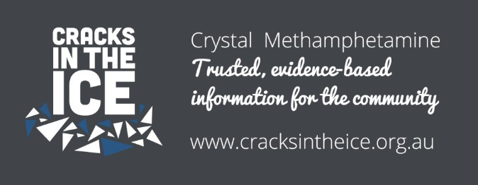

EXECUTIVE SUMMARY
This submission responds to the three areas identified in the Inquiry’s Terms of Reference:
- The nature, prevalence and impact of crystal methamphetamine (‘ice’) and other illicit amphetamine type stimulants (‘ATS’);
- the adequacy of existing measures to target ice and illicit ATS in NSW; and
- options to strengthen NSW’s response to ice and illicit ATS, including law enforcement, education, treatment and rehabilitation responses.
An important observation is that, although overall methamphetamine rates have declined in Australia for the last decade, there has been a significant change in the type of methamphetamine being most commonly used [1]. The switch from the less potent forms of methamphetamine (speed and base) to the more potent form, crystal (‘ice’), has resulted in increased harms, not only to people who use ice but also their families, friends, communities and workplaces [2]. In the 2016 National Drug Strategy Household Survey, 57% of people who used methamphetamine in the past 12 months reported using ice as their main form of methamphetamine compared to only 22% in 2010 [1]. In the same survey, methamphetamine overtook alcohol as the drug perceived to be of most concern to the general Australian community, with 40% of people surveyed electing it as the drug of most concern (vs 28% for excessive alcohol use).
Since the increase in the use of ice, there has also been an overall rise in methamphetamine-related harms such as increased number of treatment episodes, hospital admissions and fatalities [3-5]. These increases are attributed to the properties of ice, which is often a purer form of methamphetamine, producing a stronger and longer lasting ‘high’.
Ice also has the potential to cause more serious side effects than other forms of methamphetamine and increases the risk of people developing dependence, psychosis, and other long-term physical and mental health problems. Given the high risk for adverse effects associated with ice use, it is important that harm reduction principles are considered by the NSW Government and implemented as appropriate to prevent both harms to individuals and unnecessary burden on the health care system.
In our submission we emphasise the importance of increasing access to evidence-based information and resources in NSW, which is achievable, quickly and effectively, through the promotion of the national Cracks in the Ice toolkit, the Family and Friends Support Program, and the Crystal Clear Program. These resources are based on a strong foundation of evidence and are well received by the Australians who have engaged with these tools.
More can be done by NSW to promote and support their uptake more comprehensively across the state, as well as to support development of additional resources to fill identified gaps in the current reach and content of these programs (e.g. adaptions for young people and peer workers).


National prevalence data also indicate that use of methamphetamine, including ice, is twice as high in regional and rural/remote communities compared to metropolitan areas, with NSW following this trend [1, 6]. Regional and rural/remote areas generally have less access to traditional services and treatments; therefore, it is important to implement prevention strategies, build resilience as well as develop and support the capacity of the health workforce to better service these areas. Also, it is essential to consider and promote innovative methods, such as online treatment and peer support, for people living in these communities where a workforce may not be physically available.
Furthermore, the Matilda Centre and CBMR highlight the importance of workplace development in general in NSW and the need to acknowledge the high prevalence of co- occurring mental health and substance use issues. One in two Australians will develop a substance use, anxiety or mood disorder in their lifetime [7-9], and one in five Australian adults meet criteria for a substance use, anxiety or mood disorder annually [9]. Co-occurring substance use and mental health issues often interact in ways that maintain one another, making it difficult for people to recover. People with comorbid substance use and mental health issues also generally experience worse overall health and wellbeing compared to people experiencing these problems in isolation. Strengthening the response of health workers in the alcohol and other drug (AOD) and mental health sectors to address the high rates of co-occurring mental health and AOD use issues is key to improving treatment outcomes across both sectors. It is likely that this will have a significant impact on rates of ice use and recovery from methamphetamine use disorders. Several promising avenues to address this imperative are detailed in this submission.
Lastly, we discuss the issues such as stigma and other barriers to care which can prevent people from opening the lines of communication about the challenges they are experiencing and to seeking treatment. It is vital that the NSW government, media outlets, and workforce use evidence-based, non-stigmatising language when communicating with the Australian public about drug use and related harms, and in particular about ice use to help reduce stigma and discrimination.


The involvement of people with lived experience as peer workers and general consultants in the development of policies is critical to ensure that policies and practices are relevant and effective for the target audiences.

RESPONSE TO TERMS OF REFERENCE
- The nature, prevalence and impact of crystal methamphetamine (‘ice’) and other illicit amphetamine type stimulants (‘ATS’);
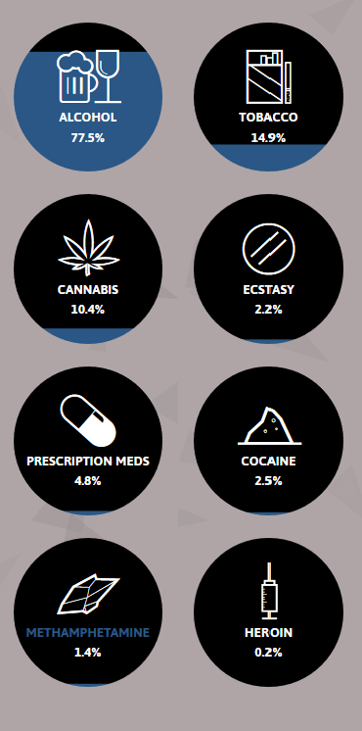
Measuring the nature, prevalence and impact of ice and other ATS in the population is difficult and many people report higher rates in their communities than are reflected in general population surveys. The data we include in our submission come from a number of sources, including population surveys, the National Wastewater Monitoring Program, hospital and other treatment centre data. Some sources identify specific drug types within the ATS group (e.g. amphetamine, methamphetamine, MDMA (3,4- ethylenedoxymethamphetamine or ‘ecstasy’))
whereas others report aggregate data for this drug class. Given ice is the principal drug of concern for this submission, where possible, we have focused on trends specifically relating to its use and associated harms.

Prevalence estimates in Australia
Relatively few Australians report using ice and other ATS compared to other drugs. The 2016 National Drug Strategy Household Survey reported that 6.3% or 1.3 million Australians over the age of 14 had ever used meth/amphetamine (including ice) and 1.4% reported recent use (in the past 12 months). Similarly, 11.2% (2.2 million) Australians over the age of 14 reported ever using MDMA and 2.2% reported recent use. The levels of recent use are low for both meth/amphetamine and MDMA compared to 10.4% for cannabis and 2.5% for cocaine (Figure 1) [1].
Of those who had used meth/amphetamine in the past 12 months, approximately 1 in 3 had used the drug at least once a month and over half (57%) reported using ice as their main form of methamphetamine, compared to 20% mainly using powder (speed).
Data from the 2018 Illicit Drug Reporting System (IDRS) indicates that one third of their national sample (910 people who inject drugs) reported methamphetamine as their drug of choice [10]. This report also found an increase in recent use of ice from 68% in 2017 to 75% in 2018. A similar trend was seen in the NSW IDRS [11]. According to the Ecstasy and Related Drugs Reporting System (EDRS) the MDMA

market has diversified over the past few years, with recent use of MDMA (last 6 months) showing an increase in the use of capsules and crystal (72%, and 62% of the sample, respectively). These changes may be due to perceived purity, with MDMA capsules and crystal reported to be of higher purity than pills and powder [12].
Figure 1: The proportion of Australians surveyed in the 2016 National Drug Strategy Household Survey who reported using these substances in the past 12 months [1].
Source: Cracks in the Ice Online Community Toolkit.

Methamphetamine use in Rural and Remote Communities
Data from a number of sources indicate rates of methamphetamine use are higher among rural and remote areas of Australia compared to regional areas and major cities. For example, the 2016 National Drug Strategy Household Survey found rates of methamphetamine use were 2.5 times higher among people living in remote or very remote areas compared to rates among those living in major cities or regional areas [1]. This is also supported by recent 2018 data from the National Wastewater Drug Monitoring Program which found that average consumption of methamphetamine in regional areas exceeded consumption in capital cities [6]. At a state level, NSW followed this national trend with a higher level of consumption found in regional areas. This indicates that improving access to evidence-based information, prevention, treatment and support for ice use among residents and affected communities in rural and remote areas should be a priority (see Recommendation 5).

Patterns of ice use among people who use methamphetamine
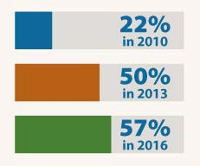
Data from the 2016 National Drug Strategy Household Survey suggest that overall rates of methamphetamine use in the general population have generally declined over the last decade [1]. Other data from this survey and hospital records indicate, however, that among people who use methamphetamine, rates of regular
and dependent use have increased. Additionally among people who use methamphetamine regularly, there has been an increase in the number of people who report using ice as their main form of the drug from 22 to 57% between 2010 and 2016 (Figure 2), while reports of speed use have decreased (from 50 to 20%) [1].
Data from the 2018 IDRS suggests similar trends are emerging among people who inject drugs.
Reports show a rise in recent use (last 6 months) of

crystal methamphetamine among people who inject drugs from 2010 to 2018 (from 39% to 75%), and a decline in recent use of speed (from 41% to 20%) [10].
Taken together these data suggest that, among people who use methamphetamine, ice is becoming a more popular form of the drug. Ice is often a purer form of methamphetamine compared to the other variants (base and speed), meaning it gives a stronger and longer lasting ‘high’, has more potent and serious side effects putting people at greater risk of dependence, psychosis, and other long-term physical and mental health problems.
Figure 2: According to the National Drug Strategy Household Survey, there has been a 36%* increase since 2010 in the use of ice as the main form of methamphetamine among people who report using the drug. Source: AIHW 2017. National Drug Strategy Household Survey (NDSHS) 2016 – key findings. www.aihw.gov.au.
*Increase was calculated based on exact percentages not rounded figures shown in chart

Various sources have reported an overall rise in methamphetamine-related harms such as increased treatment episodes, hospital admissions and fatalities (Figure 3) [3-5] . For example, methamphetamine-related death rates doubled in Australia from 2009 to 2015, with toxicity found to be the most frequent cause [3].

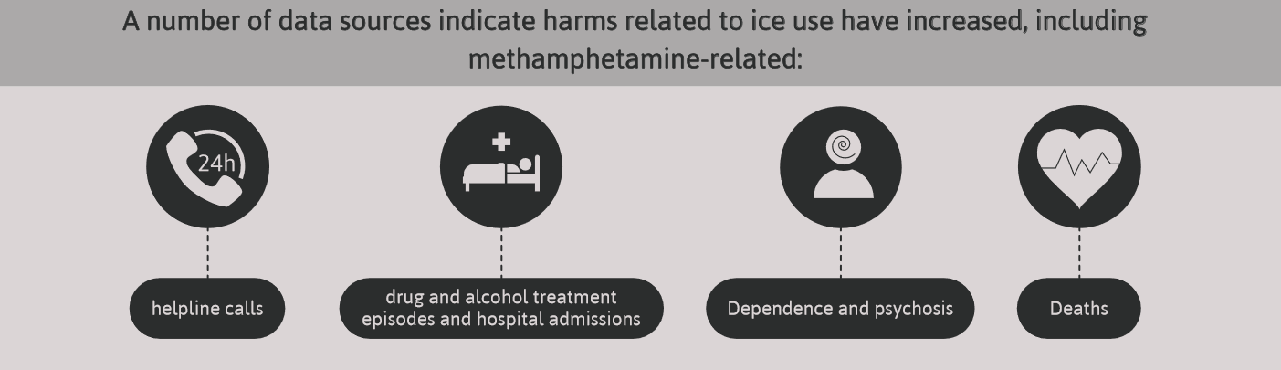
Figure 3: Over the last 10 years there has been an overall rise in methamphetamine related harms, which include an increase in the number of helpline call, treatment episodes, hospital admissions and fatalities.

Impact of ice
The effects of ice can be far reaching, impacting not only those using ice but also families, friends, communities and workplaces. In the latest National Drug Strategy Household Survey (2016), methamphetamine overtook alcohol as the drug perceived to be of most concern to the general Australian community, with 40% of people surveyed electing it as the drug of most concern (vs 28% for excessive use of alcohol). Methamphetamine was also the drug that Australians most frequently associated with a ‘drug problem’ in the 2016 survey and its nomination rate has more than doubled since 2013 (22% to 46% in 2016) [1].
It is also worth noting that the 2016 National Drug Strategy Household survey found that Aboriginal and Torres Strait Islander people were 2.2 times more likely to use meth/amphetamines than non-Indigenous people. It has also been found that Aboriginal and Torres Strait Islander people are experiencing a disproportionate burden of harm from amphetamines, including methamphetamine [13].

Impact on people who use ice Physical and mental effects
The effects experienced by people using methamphetamines such as ice can include physical problems (see Figure 4) and mental health symptoms (Figure 5). Effects can be short term or long term depending on the dosage, frequency and length of use.
The initial effects of ice often last for between 4 and 12 hours depending on how much is consumed. Although the effects of ice are usually felt quickly (within minutes if it is smoked or injected, or about 30 minutes if snorted or swallowed), it can take 1 to 2 days to entirely leave the body [14]. As previously mentioned, in some cases the use of methamphetamine, particularly ice, can be fatal due to overdose, stroke, natural diseases (such as coronary disease), suicide or accidental injury [3].
A 'comedown' phase or ‘crash’ is often experienced by people who use ice as the drug starts to wear off. These feelings can last a few days and symptoms can include feeling down or depressed, exhausted, irritable and anxious [14, 15]. People who become dependent on ice also experience severe withdrawal symptoms that can last for several days or many weeks, including headaches, cramps, vomiting, anxiety and restlessness [15]. For some people, mental health symptoms experienced when using methamphetamines such as ice do develop into mental disorders, such as anxiety, depression and psychosis [16].

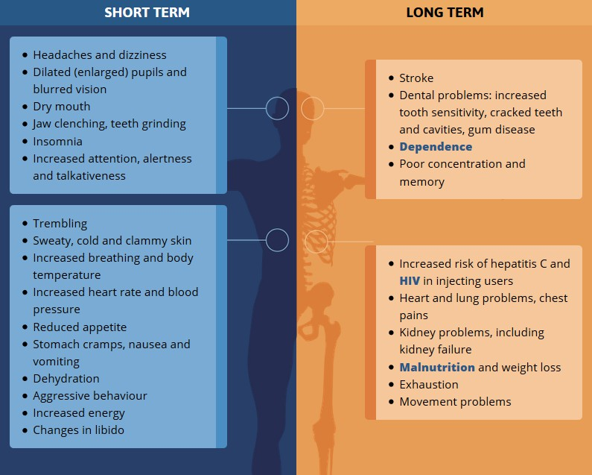
Figure 4: Ice can have a range of both short-term and long-term physical effects depending on the frequency, duration and dose of methamphetamine used [14, 16, 17]. Heavy frequent use is associated with more serious side effects such as psychosis and dependence [14, 18].

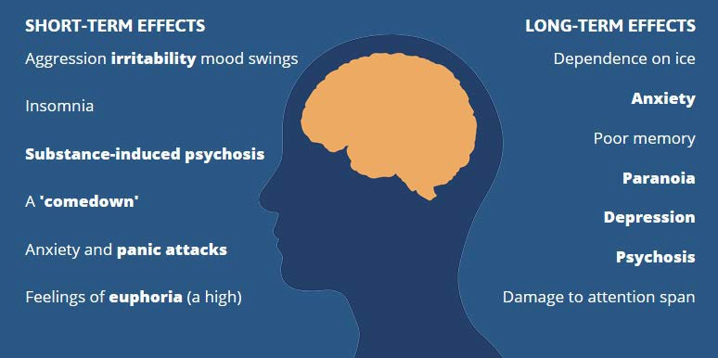
Figure 5: People who use ice can experience mental health symptoms which may last a few days to a few weeks [14].

Given the potentially serious physical and mental health effects that can happen when someone takes ice, it is important for people who use ice or plan to use ice to consider harm reduction principles (see Recommendation 8). Some harm reduction principles include [19-21]:
- Staying hydrated and taking time out to rest if needed. Ice can increase heart rate, blood pressure and temperature, which can develop into more serious health conditions if not adequately managed.
- Avoiding the use of other substances at the same time as combining ice with other drugs, including alcohol and caffeine, can lead to unpredictable side effects.
- Being aware that ice may be mixed with other drugs (e.g. ketamine) or substances (e.g. glucose) prior to being sold, and these impurities can potentially cause other adverse effects [22]
- Using safe sex practices, as ice can lower inhibitions and can increase sexual desire, it is important to be prepared.
- Being aware of safe injecting practices. There are several health harms associated with injecting ice, including increased risk of blood borne viruses (such as Hepatitis C Virus (HCV), Human Immunodeficiency Virus (HIV)), infections at the injection site, and vein damage [16]. Despite generally high awareness of the risks associated with injecting and sharing needles or any injecting equipment, it continues to be one of the main routes for administration [23].
- Knowing the signs of toxicity (overdose). People should be encouraged to know what signs to look for and when to seek help or call an ambulance if they suspect themselves or a friend may be having an overdose.

Co-occurring substance use and mental health disorders
The co-occurrence of substance use disorders (including crystal methamphetamine use disorder) and mental health disorders is common and associated with considerable societal and economic burden (Figure 6). One in two Australians will develop a substance use, anxiety or mood disorder in their lifetime [7-9], and one in five Australian adults meet criteria for a substance use, anxiety or mood disorder annually [9]. Furthermore, findings from the most recent Australian National Survey of Mental Health and Wellbeing (NSMHWB) show that these disorders frequently co- occur with 35% of individuals with a substance use disorder (31% of men and 44% of women) also meeting diagnostic criteria for at least one co-occurring mood or anxiety disorder [7].

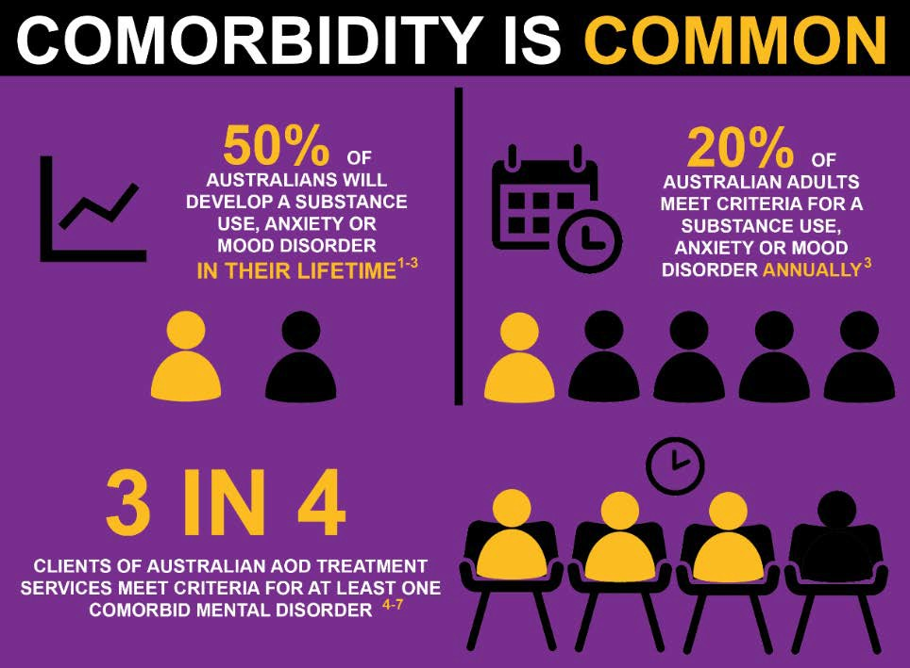
Figure 6. Summary of key statistics outlining the incidence and prevalence of co-occurring substance use and mental disorders. Source: Mills, K., et al. (2019). Submission to the Australian Government Productivity Commission Mental Health Inquiry: Lessening the Burden of Comorbid Substance Use and Mental Disorders Through Evidence-Based Care: The Case for a National Minimum Qualifications Strategy.
Prevalence is even higher among individuals entering alcohol and other drug (AOD) treatment programs, with estimates indicating between 50–76% of Australian clients of AOD treatment services meet diagnostic criteria for at least one comorbid mental disorder [24-27]. Co-occurring substance use and mental health issues often interact in ways that maintain one another, making it difficult for people to recover and people with comorbid substance use and mental health issues also generally experience worse overall health and wellbeing compared to those who have just one of these conditions.
The economic burden of these conditions is significant. Estimates from a 2016 report commissioned by The Royal Australian & New Zealand College of Psychiatrists (RANZCP) and the Australian Health Policy Collaboration at Victoria University (AHPC) show that in Australia, the annual cost of premature death due to co- occurring mental and physical health conditions in people with serious mental illness is $15 billion, and that this increases dramatically to $45.4 billion when substance abuse is also accounted for [28]. It is critical that treatment services are well equipped to attend to both substance use and mental health issues to produce the best results for clients attending AOD treatment services.
Strengthening the response of health workers in the AOD and mental health sectors to co-occurring mental health issues is key to improving treatment outcomes and there are clear opportunities for achieving this in NSW (see Recommendation 4).

Stigma
People who use illicit drugs such as ice also report experiencing stigma associated with their drug use. We recently conducted an online community survey of a large sample of Australian residents (N=2,117) including people who use ice, their family and friends, health professionals and general community members. Questions were

included to assess attitudes towards the drug ice, as well as towards people who use ice. Results indicate that 45 to 65% of the Australians in our sample judge people who use ice negatively and have a negative attitude towards them (Figure 7). There is also a substantial group of Australians, however, who express support for the need to change attitudes towards people who use ice, with approximately 42% of our sample believing people who use ice are mistreated in our society and 46% believing people should be more empathetic and understanding towards people who use ice (Figure 7).
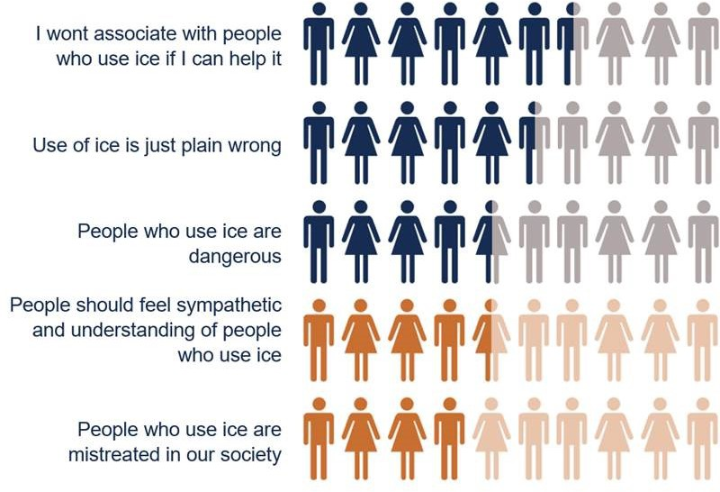
Figure 7: Stigmatising attitudes towards people who use ice are common in Australia, however a fair proportion of people recognise the presence of stigma and discrimination. Chart shows proportion of participants who selected “agree” or “strongly agree” on a 5-point Likert scale where one human figure represents 10% of the total sample (N=2117).
The survey also asked people who use ice whether they had ever experienced discrimination because of their use. Among people who reported using ice at least once a month, or more (n=90), 70% had experienced some form of discrimination.
Stigma is a negative impact that needs to be addressed in its own right. However, it also needs to be addressed as it is identified as a major barrier to people seeking help (see section B). Providing people with sources of information that offer trusted, evidence-based, non-judgemental information about drugs like ice, is an important step towards overturning the stigma surrounding these drugs (see Recommendation 6).

Impact on family and friends
Use of ice not only affects people using the drug, but also has an adverse impact on their family and friends. Family and friends can feel stress, anxiety and worry about their loved one’s ice use and can also come into interpersonal conflict with their loved one.

The scale of this problem is significant. In 2015, the Australian Government established a National Ice Taskforce to advise the Government on the impacts of ice in Australia and drive the development of a National Ice Action Strategy. On the matter of how ice impacts families, the Taskforce received over 500 submissions from the Australian community and this was the most commonly raised concern among the public submissions [29]. We have been able to further investigate the scale of this issue via online community surveys conducted during the development of Cracks in the Ice (CITI; www.cracksintheice.org.au) [2]. In one online community survey of 451 Australian community members, 29% (n=130) of participants reported having experienced family or relationship problems because of their own or someone else’s ice use and 20% (n=86) reported having been pushed, hit or assaulted by someone who used ice. In another online survey of 39 Australians who were family members or friends of people using ice, the participants stressed that supporting someone using ice is extremely challenging. Specifically, participants reported high levels of psychological distress (e.g. depression, anxiety, hopelessness), as well as significant changes to lifestyle and relationships because of their loved one’s ice use.
Family and peer support networks are critical to a persons’ recovery from drug use [30]. Too often, however, people using drugs become estranged from their families and disenfranchised from their social networks because of interpersonal conflict and emotional fatigue. Through our online survey and in-depth interviews of affected family members and friends, two clear needs were identified to better assist them in their support role: remove gaps to effective treatment and rehabilitation services for the person using ice (see Recommendations 5 and 6) and provide targeted support (emotional, practical and financial) for family and friends (see Recommendation 3).

The adequacy of existing measures to target ice in NSW
In our work with members of the Australian community who have been affected by alcohol and other drugs (including ice) we often receive feedback about the inadequacy of existing support structures in the states and territories. As mentioned in section A
  - Family and friends need more support for themselves (see Recommendations 3 and 4)
  - People are feeling immense stigma surrounding this drug and more needs to be done to combat this (see Recommendation 6)
In addition, we frequently receive feedback from family and friends who are having difficulty navigating the healthcare system and/or reporting long waiting times for their loved ones trying to enter AOD treatment. Through our online survey of 39 Australians who were family members or friends of people using ice, one of the main concerns people had was not being able to get their loved one into treatment or rehabilitation.
Further research indicates delays in accessing treatment for methamphetamine use disorder can stretch up to 5 or more years [31]. Together this evidence demonstrates a clear need to provide more treatment and rehabilitation services (see Recommendation 5).
In our recent community survey, we also asked people who use ice monthly or more (n=90) about perceived barriers to care. The preliminary national data shows that approximately a quarter of the respondents prefer to manage themselves rather than seek professional help. Another main barrier to care people reported was “I was afraid of what others would think of me”. This indicates that stigma and fear of judgment from

others is preventing people who may be using ice at frequent levels from seeking help (see Recommendation 6).
We also asked people who have ever used ice (n=567) to rate the availability of health services (both public and private) that provide support to people who use ice.
Preliminary national data from the survey indicates that a third of people find the availability of services average (Figure 8), with 1 in 4 describing it as poor and 1 in 8 describing it as extremely poor. Respondents in NSW (n=144) followed a similar trend with approximately a third of people describing availability of services as poor or extremely poor (Figure 8).
What is the availability of health services in your area, offered by public and private health facilities, that provide support to people who use ice? (%)
40
35
30
25
20
15
10
5
0
Extremely poor
Poor
Average
Good
Excellent
National (n=567) NSW (n=144)
Figure 8: One third of who had used ice before rated the availability of health services (both public and private) that provide support to people who use ice as average on a 5-point Likert scale. One in 4 described availability of health services as poor and 1 in 8 described it as extremely poor.
National data from the NDSHS indicates that ice use is approximately 2x higher in rural and remote regions compared to regional or metropolitan areas. The latest wastewater report also indicated that in NSW, consumption of methamphetamine is higher for regional areas compared to metropolitan areas. Examining the national results from our community survey regarding the availability of health services (public and private) in metropolitan, regional and rural/remote areas, we found that people in regional and rural/remote areas who have used ice before generally rate the availability of services as poorer than their metropolitan counterparts (Figure 9). For example, 59% of people in rural/remote and 46% of those in regional areas who had used ice before rated availability of services as poor or extremely poor. This compares to a figure of 31% in metropolitan areas.

What is the availability of health services in your area, offered by public and private health facilities, that provide support to people who use ice? (%)
40
35
30
25
20
15
10
5
0
Extremely poor
Poor
Average
Good
Excellent
Metropolitan (n=344)
Regional (n=177)
Rural/Remote (n=46)
Figure 9: More than half of people surveyed from regional and rural/remote areas of Australia who had used ice before rated the availability of health services (both public and private) that provide support to people who use ice as poor to extremely poor on a 5-point Likert scale.
Ratings were more negative in these areas compared to metropolitan regions.
Given that rural and remote locations generally have low accessibility to traditional treatment options, it is important to consider innovative ways of providing treatment and support as well as increasing accessibility to traditional AOD services. Online websites and programs such as Cracks in the Ice and FFSP, which are existing national resources, are one way to overcome structural and geographic barriers. Cracks in the Ice also has a mobile application ‘app’ which was developed to be a condensed version of the toolkit with offline capabilities which allow people to access the evidence-based information and resources even when internet connection is poor.

Options to strengthen NSW’s response to ice and illicit ATS, including law enforcement, education, treatment and rehabilitation responses

- Strengthen prevention by increasing access to evidence-based information and resources in NSW (see Recommendation 1)
Ensuring people have access to evidence-based information about the effects of ice and illicit ATS can help prevent use of these drugs and associated harms. Online approaches to disseminating evidence-based information have the advantage of maximising reach as they stand to overcome geographic, structural and attitudinal barriers to accessing information and support via other sources.
Cracks in the Ice (CITI; www.cracksintheice.org.au) is one such initiative that aims to increase access to trusted, evidence-based information and resources about ice via online channels. CITI was developed in response to the Final Report of the National Ice Taskforce which was established in 2015 by the Australian Government to provide advice on the impacts of ice in Australia [29]. The report stated that “The first priority must be supporting

families, workers and communities to better respond to people affected by ice” and recommended that an online toolkit be developed to provide information and resources to support families and communities to better understand and respond to the problems caused by ice. The toolkit provides the Australian community with evidence-based answers to common questions such as “What is ice?” “What are the effects of ice?” “Why do people use ice?” as well as more targeted information and resources for key populations such as family and friends, health professionals and local communities [2].

The toolkit aims to prevent initiation of ice use by educating the public about the effects of ice. The toolkit also aims to facilitate early intervention for ice use by providing a brief online screener assessing people’s level of use, clear instructions on where to get help (e.g. GP, AOD hotlines, online services), as well as evidence-based screener and intervention tools for health professionals working with AOD clients. In addition, the toolkit aims to help family and friends and health professionals prevent harms to themselves and others when responding to someone experiencing ice-related issues and to build capacity among health care professionals working with people who use ice via linking them to evidence-based information, guidelines and training.
The toolkit also aims to reduce the stigma and discrimination associated with ice use through the use of non-judgemental language and a clear focus on evidence-based information.
In the two years since its launch on 3rd April 2017, the toolkit has received traffic from >230,000 unique visitors and has responded to 239 requests for information or assistance. The Australian community has also expressed a keen interest in the hard copy information booklets and flyers available on Cracks in the Ice with >108,000 of these resources distributed so far, as well as the CITI webinar series (7 webinars) that has received a total of 4,216 views. In 2017 CITI received the Australian Rotary Health Knowledge Dissemination Award in recognition of the important role CITI plays in disseminating evidence-based information and resources to the community.
This high level of interest in CITI demonstrates there is a clear need for information among the Australian public. Positive responses to CITI from the community also indicate that it is a useful and engaging resource for community members.
Looking at NSW specifically, 54,032 unique visitors (30.06% of Australian visitors) have so far accessed the toolkit. With online spaces becoming

increasingly crowded and advertising markets ever more competitive, more can to be done to increase awareness of this trusted and useful web resource both nationally and in affected states such as NSW. In a recent pilot study of paid Facebook advertising we were able to achieve a reach of 422,555; 10,390 landing page views and 1.24% click through rate which is well above market average (current benchmark across industries is 0.90%). There is opportunity for NSW to lead the way in promotion and ensuring a consistent evidence-based voice is provided to the community and people working in this area via increasing access to an already established and well received evidence-based resource in NSW.
The Matilda Centre is also currently developing a culturally appropriate adaptation of the CITI toolkit specifically for the Aboriginal and Torres Strait Islander population in Australia. This adaptation will help provide relevant, evidence-based, culturally appropriate information and resources.

Provide more support for prevention and early intervention approaches (see Recommendation 2)
Effective prevention and early intervention can significantly reduce disease burden by halting, delaying, and interrupting the onset and progression of disorders [32-37]. Currently Australia spends only 1.7% of total health expenditure on prevention, less than two thirds of all other OECD countries [38]. Therefore, better investment into prevention and early intervention would strengthen NSW’s response to ice and its related harms.
School-based AOD education has been shown to prevent AOD use later in life [33, 35-37]. It is critical that teachers, parents and students have access to evidence-based resources. Positive Choices (www.positivechoices.org.au) is an online portal, funded by The Australian Government Department of Health designed to meet this need, providing evidence-based drug education resources to teachers, parents and students across Australia. Since launching in December 2015, Positive Choices has been accessed by more than 480,000 unique visitors, who have viewed more than 1 million pages.
Over one third of site visitors from Australia have come from NSW (36.36% of Australian visitors, 96,106 unique visitors). Positive Choices has received several National Awards including the Australian Rotary Health Knowledge Dissemination Award (2014) for excellence in bridging the gap between knowledge gained through research and the dissemination of that knowledge to clinicians, consumers and carers, and its implementation into policy and practice. In 2017, Positive Choices was awarded the Mental Health Promotion and Wellbeing Mental Health Matters Award as part of Mental Health Month. The awards are to acknowledge work to improve understanding, awareness, service provision and the general mental health of communities in NSW over the past year.

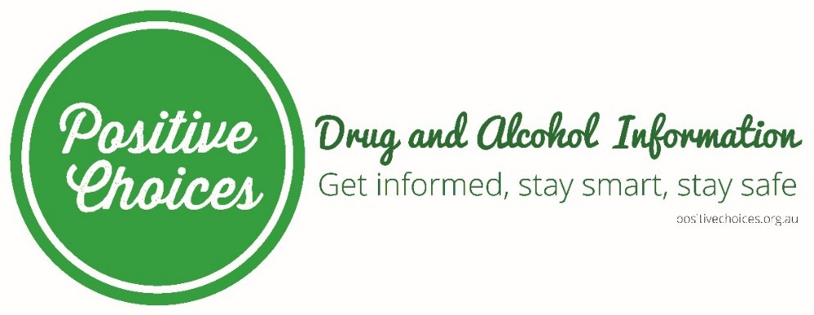
There are also several evidence-based school AOD programs available through the Matilda Centre such as Climate Schools. Specifically, in relation to methamphetamine, there is a module titled “Psychostimulant & Cannabis Module”. The effectiveness of the Psychostimulant & Cannabis module has been established using a cluster randomised controlled trial of 1,734 students in 21 schools across NSW and ACT. This trial was run between 2008-2009 and included follow-ups at 5 and10 months post intervention. Compared to those in the control group (usual drug education), students in the intervention group (Psychostimulant & Cannabis module) showed significant improvements in cannabis and psychostimulant knowledge as well as a decrease in pro-drug attitudes. In addition, the intervention group showed a decrease in uptake and plateauing of frequency of ecstasy use and decrease in intentions to use methamphetamine and ecstasy in the future. When looking at girls specifically, students in the intervention group showed a significant decrease in frequency of cannabis use. In addition, program evaluation showed that students rated the program as an enjoyable means of delivering drug education in schools and teachers would recommend the program to colleagues [39].


It is important to acknowledge that prevention in young people is also about preventing transition to AOD use in young people at risk (e.g., with anxiety, depression, or related mental health problems), and providing programs that intervene early in a young person’s mental health journey to assist them to develop strategies that promote resilience, coping, improved physical health, and alternative pathways to drinking alcohol and using other drugs.
Early intervention is also an important strategy in addressing the need for people to use ice. Our online program Crystal Clear (www.crystalclear.org.au, formerly Breaking the Ice) has shown particular promise in this area. The development of Breaking the Ice was originally funded by The Australian Government Department of Health. We evaluated Breaking the Ice using a randomised controlled design with a wait-list control (intervention n=81, control n=79) [40]. Relative to the control group, people who received

Breaking the Ice were significantly more motivated to reduce their drug use, significantly more likely to seek help for their drug use and were significantly more engaged in their usual day-to-day activities, with fewer ‘days out of role’. Those who completed the program reported significantly higher intentions to engage with traditional AOD treatment services at the end of the study than did controls, and also reported higher actual help seeking for ice use than did controls at follow-up. In 2016, funding from the NSW Ministry of Health was provided to redevelop the original program to address crystal methamphetamine use in young Australians (aged 16-25 years, Crystal Clear). Crystal Clear incorporates cognitive behaviour therapy and motivational enhancement strategies to encourage people to consider their broader lifestyle and the impact that crystal methamphetamine is having on work, home, study, sleep, health, and mental health. We actively engaged with young people (aged 16-25 years) for the redevelopment of this tool, incorporating relevant personal stories, examples, and design elements matched to the needs and preferences of this age group.
Crystal Clear could be expanded to include additional modules on coping skills, stress management, relationship and communication building skills, identification and management of comorbid mental health problems, and relapse prevention. It could be integrated with other existing tools in NSW (e.g., S-Check, St Vincent’s Hospital) to provide a comprehensive screening and early intervention package to people using crystal methamphetamine wherever they are located throughout NSW. Integrating these tools with traditional AOD treatment services and Stimulant Clinics could form an innovative and effective strategy to broaden the scope in addressing crystal methamphetamine use and harms in affected individuals.


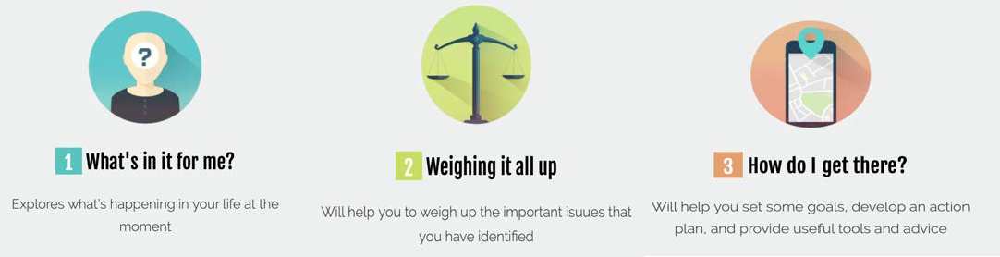

A recent evidence check, commissioned by NSW Ministry of Health, highlighted the critical role that peers play in reinforcing both positive and negative attitudes and behaviours around AOD use, including crystal methamphetamine [41]. This is true for both the initiation of use and engaging in treatment for AOD-related harms. Peer-led interventions for at risk youth

have the potential to overcome the implementation barriers and the stigma associated with seeking help for alcohol and drug use problems, provide education and reduce their harm.
The evidence check identified the most common and effective peer-led models in AOD use prevention and early intervention were those:
- Used to enhance more comprehensive programs of substance use prevention, and not as standalone approaches;
- Implemented for preventing initial use/uptake of substances, but are not effective for non-using groups when administered by peers that have a current or previous history of use;
- Focused on preventing or reducing secondary harms of AOD use in non- using peers;
- Where the selection of peers is made carefully to ensure that they are highly credible among the target population for the desired behaviour and that they are not engaging in activities that are the focus of intervention
- Committed to adopting the behaviour desired from an intervention in order to maximise its effectiveness.
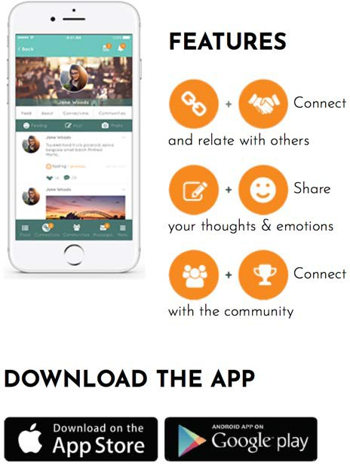
At the time of the evidence check, no Australian research had tested or reported on peer-led interventions specifically for ice use and harms. Thus, there exists a unique opportunity for NSW Health to actively engage peers with a lived experience of ice use in prevention, early intervention, and treatment planning and implementation activities. Our team has developed and trialled the first app-based program to facilitate peer-to-peer supportive interactions, with moderation provided by health professionals. Incorporating the principles of effective peer-led interventions in AOD treatment, the app (BreathingSpace) was tested with success in a randomised controlled trial among
young people (aged 18-30 years) with depression and alcohol use disorders [42]. It is suggested that this tool be expanded to apply to ice use to act as a mechanism to engage peers and lived experience voices in prevention and early intervention activities, encourage treatment seeking for ice use and related issues, and encourage pro-social activities and attitudes around ice use and harms.

Increase support for family and friends (see Recommendation 3)
The effects of ice use extend well beyond the individual using the drug. Ice use can have a profound impact not only on the person using the drug but also on their family members and friends. Supporting someone who is using ice can be extremely challenging, isolating and emotionally distressing. Families and friends can also play a critical role in the recovery of people using ice, however these relationships often breakdown leaving the person using ice isolated. Increasing access to support services for families and friends of people who use ice is important for reducing the impact of a loved ones’ ice use on them and may also help build their capacity to support their loved through recovery. It is unusual for

AOD services to be funded to provide support directly to family members and friends, and this often takes the form of supporting the family member/friend to encourage treatment seeking in the person using ice, and in supporting that person’s journey towards recovery. However, family members and friends themselves are at high risk for developing mental health and AOD problems of their own, and require support tailored to their unique experiences of supporting a loved one using crystal methamphetamine.
The Family and Friends Support Program (FFSP; www.ffsp.com.au) was funded by the Australian Government Department of Health in 2016 as an enhancement to the Cracks in the Ice Online Toolkit. FFSP is an online resilience and wellbeing program to support affected friends and family members of people who use methamphetamine. It was developed in close consultation with family members and friends who were supporting a loved one using ice, and thus has a very strong lived experience voice throughout the program.


The program provides affected family and friends with a tailored, evidence- informed website and support program that addresses their needs in supporting a loved one using crystal methamphetamine ‘ice’. This is the first, and only, evidence informed program worldwide to offer 24/7 support to family members and friends affected by a loved one’s use of crystal methamphetamine;
The FFSP is currently being piloted in Victoria. Since the pilot commenced there has been a high degree of engagement with the online program, with 799 unique visitors to the site, 50.3% returning to the site. Visitors to the site viewed 13 pages per session and spent 12 minutes on the site per session.

Given the success so far of the FFSP pilot in Victoria, there is an opportunity for FFSP to be expanded into NSW and provide much needed support to affected families and friends of people who use ice.

There is also an opportunity for the NSW government to lead the way in supporting development of new ground-breaking adaptions of the FFSP programs. Support for young people who are living in families affected by ice (either through use of ice by a parent or sibling) is urgently needed. The development of a tailored FFSP for young people who are acting as carers could help provide them with the skills to support their family members with their ice issues and serve as a prevention or early intervention to safeguard their own mental health and wellbeing. Secondly, an expansion of BreathingSpace peer-to- peer app-based intervention is recommended for all families and friends completing the FFSP online program as a means to reduce social isolation, encourage supportive discussions, and provide 24/7 support for families and friends affected by a loved one’s use of ice. Thirdly, it has been identified that ice is a problem in regional and rural/remote areas of Australia. The development of a module of FFSP for teachers in regional and rural/remote areas may help support young people affected by ice to seek help, develop resilience skills and feel more confident when responding to issues related to ice.

Strengthen response of NSW’s health workforce (including AOD workers) to people who use ice and their loved ones (see Recommendation 4)
  - Build capabilities in comorbidity
Strategies for strengthening the response of AOD workers to co-occurring mental health issues have already been executed through the Minimum Qualification Framework (MQF) currently operating in Victoria and the Australian Capital Territory [43]. This strategy has been well received by AOD workers, yet co-occurring substance use and mental disorders remain the most frequently requested area for further training [44, 45].
This topic has also recently been the subject of a submission to the Australian Government Productivity Commission Mental Health Inquiry made by the Matilda Centre [46].

We suggest three key solutions for NSW: firstly, a state-wide rollout of the MQF for AOD workers with a greater emphasis within the four key competencies of the MQF on identifying and responding to co-occurring substance use and mental disorders.

Secondly, we propose integrating existing evidence-based training and educational resources into core training as part of the MQF to ensure the four competencies include evidence-based training for comorbidity. One such resource may be the Australian Government Department of Health funded National Comorbidity Guidelines Online Training Program.

In 2007, the Australian Government Department of Health and Ageing funded the development of ‘Guidelines on the management of co- occurring alcohol and other drug and mental health conditions in alcohol and other drug treatment settings’ [47] as part of the National Comorbidity Initiative to improve the capacity of AOD workers to respond to comorbidity. The resource was a huge success [48]. Since their publication in 2009, over 12,000 hard- and electronic-copies were distributed to clinicians and treatment services across Australia.


The Guidelines provide AOD workers with a range of evidence-based options for identifying, managing and treating mental health symptoms within a holistic health care approach, involving multiple services, and integrated care coordination. Due to considerable growth in the evidence- base for the management and treatment of comorbid disorders in recent years, the Australian Government Department of Health funded the update and revision of the Guidelines in 2014. Since launch in 2016, more than 7,000 electronic and hard-copies of the updated Guidelines have been distributed to services across Australia. In 2017 an interactive online

training program was developed to compliment the Guidelines. Over 1,600 users have registered for online training and average page views have remained 31,000+ per month. In recognition of the clinical utility and impact of the Guidelines and Online Training Program, the developers were awarded the Australian Rotary Health Knowledge Dissemination Award in December 2016; and the Australian Drug Foundation Excellence and Innovation Award in Research in June 2017.

The National Comorbidity Guidelines Online Training Program holds enormous potential for upscaling at a national level, and by being incorporated into a national MQF rollout, would greatly enhance AOD workforce capacity to identify and manage comorbidity in healthcare settings throughout Australia.

Thirdly, we propose the implementation of the Dual Diagnosis Capability in Mental Health Treatment (DDCMHT) [49] and Dual Diagnosis Capability in Addiction Treatment (DDCAT) [50] toolkits in NSW mental health and AOD treatment services to improve comorbidity competency. People with lived experience of comorbidity report receiving disparate care and accessing services that do not adequately address their comorbidity. The DDCMHT and DDCAT standardised toolkits have been developed in the United States and are designed for mental health treatment services and AOD treatment services, respectively, to assess capability of addressing comorbidity. Guided by the toolkit scoring criteria, services are rated on several dimensions and the sum of these ratings indicates whether services are i) addiction/mental health only, ii) dual diagnosis capable, or iii) dual diagnosis enhanced, and provide guidance as to how to improve. These toolkits have the potential to significantly improve the standard of care for many Australians living with comorbidity as they help determine how mental health and AOD services could work towards better addressing the experiences and treatment needs for comorbidity [51]. The Matilda Centre currently receives funding from the NSW Ministry of Heath under the NSW Health Early-Mid Career Fellowships Scheme to adapt and pilot the implementation of these Toolkits in NSW services. This work was recently awarded the Australian Therapeutic Communities Association (ACTA) Excellence in Research and Evaluation Award. Further support could enable broader rollout of the Toolkits in NSW.

Align with national mental health initiatives
The significant interplay between work and the mental health of staff is well recognised. Staff in mental health and AOD treatment services are at high risk of experiencing mental health problems. Workplaces need to strive to provide inclusive and supportive workplace environments, as poor mental health can not only be a problem in itself but can also put people at an increased risk of developing substance use issues. NSW should align with Australian Government activities to improve the health and wellbeing of workplaces, in particular by supporting the National Mental Health Workplace Initiative, which was recently announced in the Federal Budget [52]. This initiative aims to provide employers, industries, small businesses and sole traders with the support needed to create a

mentally healthy workplace. Of particular relevance to this Inquiry, we encourage NSW to support the development of the National Mental Health Workforce Strategy, announced in the 2018-19 Mid-Year Economic and Fiscal Outlook, to provide options to attract, train and retain mental health workers to support the provision of mental health services across Australia as recommended by the National Mental Health Commission in April 2019 [52].

Provide specialised training for working with people who use ice
The effects of ice and the needs associated with this particular drug require a specialised response from AOD workers. The Victorian government recently funded state-based training as part of its Ice Action Plan. 360Edge (www.360edge.com.au) is the main provider in Victoria delivering tailored ice training to frontline workers. National online training is also available through NCETA and similarly has been funded through the Victorian Ice Action Plan [53]. A similar strategy of providing support for ice specific training of frontline workers in NSW could also be adopted by the NSW government.

Provide specialised training for working with family and friends of people who use ice
The previously described FFSP also aims to provide health workers with access to evidence-based training and accreditation (the 5-Step Method), information, and a referral pathway which assists families and friends they encounter as part of their usual practice.
This workforce training component of FFSP is currently being evaluated in Victoria. The training for health workers occurred in December 2017 for clinical and community staff of the Mornington Peninsula Primary Care Partnership, associated mental health and alcohol/other drug services, and members of the Frankston Local Drug Action Team (LDAT).
Professor Velleman and Ms Velleman (accredited 5-Step Method trainers) provided 5-Step Method training to 36 attendees. The training was very well rated and received by the attendees. Pending results of the evaluation of the training and online program, it is recommended that FFSP training for health professionals also be rolled out in NSW.

Increase access to treatment and rehabilitation (see Recommendation 5)
There is a general need to increase public AOD treatment and rehabilitation services and facilities in all areas of NSW, particularly in rural and regional areas. As previously shown, the use of ice is reportedly higher in rural and regional areas and reported availability of services is lower. One way to increase access is through the support of online methods of treatment and support (for example Crystal Clear, Breathing Space, FFSP, Cracks in the Ice), as rural and remote locations are often far away from traditional treatment options.

Break down stigma and encourage help-seeking (see Recommendations 6 and 7)
As discussed in section A and B, we recently conducted a community survey of a large sample of Australian residents (N>2000) that demonstrated there is a high level of stigma surrounding ice use. In addition, our preliminary data indicates

that stigma acts as a significant barrier to help seeking among people who use ice. When people who reported having used ice monthly or more frequently (n=90) were asked what they thought the main barrier was that preventing them from seeing help for problems related to ice use, the two most commonly selected statements were “I preferred to manage myself”, followed by “I was afraid of what others would think of me”.
Providing people with sources of information that provide trusted, evidence- based, supportive information about drugs like ice, rather than inflammatory or stigmatising content, is an important step towards overturning the stigma surrounding these drugs. CITI is one such resource providing a calm, evidence- based voice in a space often cluttered by alarmist, stigmatising and incorrect information.
Messages conveyed by news media and government advertising can play a considerable role in the nature of public beliefs and attitudes regarding alcohol and other drugs. Mindframe is a project funded by the Australian Government Department of Health that has developed resources and guidelines to support the media and other institutions to communicate about alcohol and other drug issues in a safe and non-stigmatising manner. Mindframe provides guidance to tertiary education, news media, public relations, other media outlets and creative enterprises on how to safely report, portray and communicate about alcohol and other drug issues (among other issues such as suicide and mental health). Any measures in NSW to support uptake and adherence to the Mindframe, in particular the guidelines for communicating about mental ill-health and communicating about alcohol and other drugs would be welcomed. This could be achieved by Inquiry staff and government officials working with the Mindframe Project Team to implement and disseminate the guidelines throughout NSW (see Recommendation 6).

Since Mindframe for Alcohol and Other Drugs launched on March 28, 2019 the AOD section of the Mindframe website has had 265 visits, the Mindframe guidelines PDF was downloaded 27 times and the Mindframe AOD help-seeking card was downloaded six times in NSW. From March 28 to April 30 2019 the Mindframe website overall had 949 total users in NSW.
From 2005- 2015 Mindframe delivered 645 media briefings with national media organisations and delivering 180 university lectures; reaching approximately 200 journalists each year. In 2018 the Mindframe website nationally had 75,200 visitors, 125,000 page views and 4,800 downloads.
Lastly, involving people with lived experience in policy making and service provision, is critical to reduce stigma produced by systemic factors that are exacerbated when those most affected by ice use and related harms do not have a voice (see Recommendation 7).

Promote the use of harm reduction strategies (see Recommendation 8)
The use of ice can lead to serious and potentially life-threatening side effects due to its potency (refer to Section A). Therefore, the promotion and encouragement to adopt harm reduction principles is essential in preventing adverse effects among people who use ice and unnecessary burden on health care systems.

Recommendations:
Recommendation 1: We recommend that access to evidence-based information and resources relating to ice use and harms be increased in NSW.
Specifically, we recommend that the NSW Government funds a targeted Cracks in the Ice brand awareness advertising campaign to raise awareness of this established resource among NSW residents.
Recommendation 2: We recommend support for further development and implementation of evidence-based prevention and early intervention programs for ice use and related harms in NSW.
Recommendation 3: We recommend that evidence-based approaches to supporting family and friends affected by loved ones using ice be implemented in NSW.
Specifically, we recommend that the Family and Friends Support Program currently being piloted in Victoria be implemented in NSW.
Recommendation 4: We recommend that methods be put in place to strengthen the response of the NSW health workforce working with clients who use ice and their loved ones.
Specifically, we recommend that:
i)

ii)

iii)

iv)

v)

vi)
The Minimum Qualification Framework (MQF) for alcohol and other drug (AOD) workers currently operating in Victoria and the Australian Capital Territory be rolled out in NSW;
The MQF integrates existing evidence-based training and educational resources for identifying and responding to co-occurring substance use and mental health problems from the National Comorbidity Guidelines;
The Dual Diagnosis Capability in Mental Health Treatment and Dual Diagnosis Capability in Addiction Treatment toolkits be adopted in NSW mental health and AOD treatment services to improve comorbidity competency;
NSW supports the National Mental Health Initiative and other national activities to improve mental health and wellbeing especially among workers Specialised training be provided to support and build capacity among NSW AOD workers working with clients who use ice;
Specialised training be provided to support and build capacity among NSW AOD workers for working with family and friends of people who use ice via the Family and Friends Support Program.

Recommendation 5: We recommend that more public AOD treatment and rehabilitation services be provided in NSW, particularly in rural and remote areas.
We recommend that special emphasis be placed on online treatment and support options to reduce the impact of ice use and related harms for people living in rural and remote communities of NSW.
Recommendation 6: We recommend that multiple parties work together to break down stigma surrounding ice use.
Specifically, we recommend the NSW government supports Mindframe and its guidelines for communicating about mental ill-health and for communicating about alcohol and other drugs. We recommend the Inquiry work with Mindframe to support Government departments, media outlets and media sources to employ Mindframe’s evidence informed recommendations and encourage the involvement of people with lived experience wherever possible in policy making across all Government responses to this issue.
We also recommend the support and expansion of the Crystal Clear online program, which is available 24/7 for people using ice (or thinking about using ice) as a low stigma, self-help, cost effective, and private alternative to traditional AOD treatments. Integrating this online tool with other technology-based screening and intervention tools (e.g., the StimCheck) is also recommended.
Recommendation 7: We recommend that the government involve people with lived experience of ice and ATS related issues when developing policies in this area to ensure new policies are acceptable and relevant to those most effected by their outcomes.
We also recommend that the government support the peer workforce, in AOD treatment settings to ensure that the insights of people with lived experience are incorporated into best practices. We recommend that the app (BreathingSpace) which incorporates the principles of effective peer-led interventions in AOD treatment, be expanded to include ice use and evaluated.
Recommendation 8: We recommend that the government implement harm reduction approaches to reduce the harms associated with the use of ice, for example through the encouragement of safe injecting practices.

REFERENCES
- Australian Institute of Health and Welfare, National Drug Strategy Household Survey 2016: detailed findings. 2017. Drug Statistics series no. 31. Cat. no. PHE 214. Canberra: AIHW. Available from: www.aihw.gov.au/reports/illicit-use-of-drugs/2016- ndshs-detailed/contents/table-of-contents.
- Champion, K.E., et al., A Web-Based Toolkit to Provide Evidence-Based Resources About Crystal Methamphetamine for the Australian Community: Collaborative Development of Cracks in the Ice. JMIR Ment Health, 2018. 5(1): p. e21.
- Darke, S., Kaye, S., and Duflou, J. Rates, characteristics and circumstances of methamphetamine-related death in Australia: a national 7-year study. Addiction, 2017. 112(12): p. 2191-2201.
- Degenhardt, L., et al., Crystalline methamphetamine use and methamphetamine- related harms in Australia. Drug Alcohol Rev, 2017. 36(2): p. 160-170.
- Australian Institute of Health and Welfare, Alcohol and other drug treatment National Minimum Data set (AODTS NMDS 2015–16). 2017. Available from: www.aihw.gov.au/about-our-data/our-data-collections/alcohol-other-drug-treatment- services.
- Australian Criminal Intelligence Commission, National Wastewater Drug Monitoring Program - Report 6, December 2018. 2018. Available from: www.acic.gov.au/publications/intelligence-products/national-wastewater-drug- monitoring-program-report.
- Slade, T., et al., Onset and temporal sequencing of lifetime anxiety, mood and substance use disorders in the general population. Epidemiology and Psychiatric Sciences, 2015. 24(1): p. 45-53.
- Kessler, R.C., et al., Lifetime prevalence and age-of-onset distributions of DSM-IV disorders in the National Comorbidity Survey Replication. Arch Gen Psychiatry, 2005. 62(6): p. 593-602.
- Slade, T., et al., National Survey of Mental Health and Wellbeing: Methods and key findings. Australian and New Zealand Journal of Psychiatry, 2009. 43(7): p. 594-605.
- Peacock, A., et al., Australian Drug Trends 2018. Key findings from the National Illicit Drug Reporting System (IDRS) Interviews. 2018, National Drug and Alcohol Research Centre, UNSW Australia: Sydney. Available from: https://ndarc.med.unsw.edu.au/resource/australian-drug-trends-2018-key-findings- national-illicit-drug-reporting-system-idrs.
- Gibbs, D. and Peacock, A., New South Wales Drug Trends 2018: Key findings from the National Illicit Drug Reporting System (IDRS) Interviews. 2018, National Drug and Alcohol Research Centre, UNSW Australia: Sydney. Available from: https://ndarc.med.unsw.edu.au/resource/new-south-wales-drug-trends-2018-key- findings-illicit-drug-reporting-system-idrs-interviews.
- Peacock, A., et al., Australian Drug Trends 2018: Key findings from the National Ecstasy and Related Drugs Reporting System (EDRS) Interviews. 2018, National Drug and Alcohol Research Centre, UNSW Australia: Sydney. Available from: https://ndarc.med.unsw.edu.au/resource/australian-drug-trends-2018-key-findings- national-ecstasy-and-related-drugs-reporting.
- Monahan, C. and Coleman, M., Ice in the Outback: the epidemiology of amphetamine-type stimulant-related hospital admissions and presentations to the emergency department in Hedland, Western Australia. Australas Psychiatry, 2018. 26(4): p. 417-421.
- McKetin, R. and Black, E., Methamphetamine: What you need to know about speed, ice, crystal, base and meth. 2014, Sydney: National Drug and Alcohol Research Centre, University of New South Wales. Available from: www.sydney.edu.au/content/dam/corporate/documents/research/matilda- centre/methamphetamine-resources.pdf

- McGregor, C., et al., The nature, time course and severity of methamphetamine withdrawal. Addiction, 2005. 100(9): p. 1320-9.
- Darke, S., et al., Major physical and psychological harms of methamphetamine use.
Drug Alcohol Rev, 2008. 27: p. 253-62.
- Australian Institute of Health and Welfare, Alcohol, tobacco & other drugs in Australia. 2018. Cat. no. PHE 221. Canberra: AIHW; Available from: https://www.aihw.gov.au/reports/alcohol/alcohol-tobacco-other-drugs- australia/contents/introduction.
- Arunogiri, S., et al., A systematic review of risk factors for methamphetamine- associated psychosis. Aust N Z J Psychiatry, 2018. 52(6): p. 514-529.
- Alcohol and Drug Foundation. Harm reduction and methamphetamine use. Breaking the Ice In Our Community Factsheet 2016; Available from: www.adf.org.au/wp- content/uploads/2016/10/nswiceharmreduction.pdf.
- Alcohol, Tobacco and other Drugs Council Tasmania Inc. Harm reduction strategies for methamphetamine users. Year unknown; Available from: http://www.nht.org.au/wp-content/uploads/2015/06/List-of-harm-reduction-strategies- for-methamphetmines-users.pdf.
- Victoria’s Youth Drug and Alcohol Advice service (YoDAA). Methamphetamine (Ice)- Fast facts for workers. Year unknown; Available from: http://www.yodaa.org.au/workers/methamphetamine-ice-fast-facts-workers.
- National Drug and Alcohol Research Centre, Methamphetamine Supply in Australia. 2006, University of New South Wales: National Drug and Alcohol Research Centre.
- Australian Government Department of Health. 10. Risks and harm prevention. Patterns of use and harms associated with specific populations of methamphetamine users in Australia - exploratory research, 2008; Available from: http://www.health.gov.au/internet/publications/publishing.nsf/Content/phd-npi- methamphetamine-report-feb09-l~risks.
- Callaly, T., et al., Prevalence of psychiatric disorder in a methadone maintenance population. Aust N Z J Psychiatry, 2001. 35(5): p. 601-5.
- Burns, L., Teesson, M. and O'Neill, K., The impact of comorbid anxiety and depression on alcohol treatment outcomes. Addiction, 2005. 100(6): p. 787-96.
- Lubman, D.I., et al., The impact of co-occurring mood and anxiety disorders among substance-abusing youth. Journal of Affective Disorders, 2007. 103(1-3): p. 105-112.
- Kingston, R., Marel, C. and Mills, K., A systematic review of the prevalence of comorbid mental health disorders in people presenting for substance use treatment in Australia. Drug and Alcohol Review, 2016. 36: p. 527-539.
- Royal Australian and New Zealand College of Psychiatrists, The economic cost of serious mental illness and comorbidities in Australia and New Zealand. 2016, Royal Australian and New Zealand College of Psychiatrists (RANZCP): Melbourne, Australia. Available from: www.ranzcp.org/files/publications/ranzcp-serious-mental- illness.aspx.
- Commonwealth of Australia, Department of the Prime Minister and Cabinet, Final Report of the National Ice Taskforce. 2015. Available from: www.pmc.gov.au/resource-centre/domestic-policy/final-report-national-ice-taskforce.
- Ward, B., et al., Family-focused practice within a recovery framework: practitioners' qualitative perspectives. BMC Health Serv Res, 2017. 17(1): p. 234.
- Lee, N.K., Harney, A.M. and Pennay, A.E., Examining the temporal relationship between methamphetamine use and mental health comorbidity. Advances in Dual Diagnosis, 2012. 5(1): p. 23-31.
- Munoz, R.F., et al., Prevention of major depression. Annu Rev Clin Psychol, 2010. 6:
p. 181-212.
- Champion, K.E., et al., A systematic review of school-based alcohol and other drug prevention programs facilitated by computers or the internet. Drug Alcohol Rev, 2013. 32(2): p. 115-23.

- Calear, A.L. and Christensen, H., Systematic review of school-based prevention and early intervention programs for depression. J Adolesc, 2010. 33(3): p. 429-38.
- Foxcroft, D.R. and Tsertsvadze, A., Cochrane review: Universal school-based prevention programs for alcohol misuse in young people. Cochrane Database of Systematic Reviews, 2011 (5). Art. No.: CD009113.
- Teesson, M., Newton, N.C., and Barrett, E.L., Australian school-based prevention programs for alcohol and other drugs: a systematic review. Drug Alcohol Rev, 2012. 31(6): p. 731-6.
- Faggiano, F., et al., Universal school-based prevention for illicit drug use. Cochrane Database of Systematic Reviews, 2014(12).
- OECD, Health at a Glance 2013: OECD Indicators, 2013. OECD Publishing. Available from: www.dx.doi.org/10.1787/health_glance-2013-en.
- Vogl, L.E., et al., A universal harm-minimisation approach to preventing psychostimulant and cannabis use in adolescents: a cluster randomised controlled trial. Substance Abuse Treatment, Prevention, and Policy, 2014. 9(1): p. 24.
- Tait, R.J., et al., Six-month outcomes of a Web-based intervention for users of amphetamine-type stimulants: randomized controlled trial. J Med Internet Res, 2015. 17(4): p. e105.
- Hunt, S., et al., Evidence for the effectiveness of peer-led education for at risk youth: an Evidence Check rapid review brokered by the Sax Institute (https://www.saxinstitute.org.au/) for the NSW Ministry of Health. 2016. Available from: www.saxinstitute.org.au/wp-content/uploads/Evidence-for-the-effectiveness-of- peer-led-education-for-at-risk-youth.pdf.
- Kay-Lambkin, F.J., et al., The iTreAD project: a study protocol for a randomised controlled clinical trial of online treatment and social networking for binge drinking and depression in young people. BMC Public Health, 2015. 15: p. 1025.
- State Government of Victoria Department of Human Services, State Government of Victoria Department of Human Services, The Victorian Alcohol and Other Drugs Workforce Development Strategy – Minimum Qualification Strategy, 2004. State Government of Victoria: Melbourne, Australia. Available from: www2.health.vic.gov.au/alcohol-and-drugs/alcohol-and-other-drug-workforce/aod- workforce-minimum-qualification-strategy
- Connolly, L., Victorian AOD Sector Qualification Review Report. 2008, Turning Point Alcohol & Drug Centre. Available from: www.nceta.flinders.edu.au/files/8612/6741/5986/ENNP7%20Connolly%202008.pdf
- Pidd, K., Roche, A. and Carne, A., The role of VET in alcohol and other drugs workforce development. 2010, NCETA: Adelaide, Australia. Available from: www.nceta.flinders.edu.au/files/3612/9800/6356/EN_Pidd_431%202010.htm.pdf
- Mills, K., et al., Submission to the Australian Government Productivity Commission Mental Health Inquiry: Lessening the Burden of Comorbid Substance Use and Mental Disorders Through Evidence-Based Care: The Case for a National Minimum Qualifications Strategy. 2019.
- Mills, K., et al., Guidelines on the management of co-occurring alcohol and other drug and mental health conditions in alcohol and other drug treatment settings. 2009, National Drug and Alcohol Research Centre: Sydney, Australia.
- Mills, K., et al., Guidelines on the management of co-occurring mental health conditions in alcohol and other drug treatment settings: How useful are they? . Mental Health and Substance Use, 2012. 5: p. 160-172.
- Substance Abuse and Mental Health Services Administration, Dual Diagnosis Capability in Mental Health Treatment Toolkit Version 4.0. 2011; HHS Publication No. SMA-XX-XXXX, Rockville, MD: Substance Abuse and Mental Health Services Administration. Available from: https://www.centerforebp.case.edu/client- files/pdf/ddcmhttoolkit.pdf.
- Substance Abuse and Mental Health Services Administration, Dual Diagnosis Capability in Addiction Treatment (DDCAT) Toolkit Version 4.0. 2011; HHS

Publication No. SMA-XX-XXXX, Rockville, MD: Substance Abuse and Mental Health Services Administration. Available from: https://www.centerforebp.case.edu/client- files/pdf/ddcattoolkit.pdf.
- Barrett, E.L., et al., Lived experiences of Australians with mental health and AOD comorbidity and their perspectives on integrated treatment. The Australian Journal on Psychosocial Rehabilitation, 2019(Summer 2018 - 2019): p. 38-42.
- The National Mental Health Commission, Submission to the Australian Government Productivity Commission Inquiry into the Social and Economic Benefits of Improving Mental Health. 2019.
- National Centre for Education and Training on Addiction, Ice: Training for Frontline Workers 2016. Available from: http://nceta.flinders.edu.au/workforce/training-and- education-1/ice-training-package/.

